**Event name:** Mathematic Workshop

**Introduction:** Sharada Shakti arranged mathematics workshop for 5thto 7th Students at Chandrakant Darode High School. The workshop was conducted by Prof. Gitanjali Phatak and Prof. Swaroop Bhalerao. They explained the concepts and formulae to the students with the help of models and by practicals. The workshop helped to reduce the fear of mathematics from Student minds.

**Organizers:** Sharada Shakti

**Speaker:** Prof. Geetanjli Phatak S. P. College Pune and Prof. Swaroop Bhalerao S. P. College Pune

**Committee:** Mrs.Simantini Vaze, Dr. Rajshree Kashalkar

**Date:** 9 April 2019

**Venue:** Chandrakant Darode High School Pune.

**No of attendees:** 80 Students

**Impact including Outcome:** Excellent experience. Prof. Geetanjali Phatak and Prof. Swaroop Bhalerao conducted session making mathematics formulae and concepts easy.

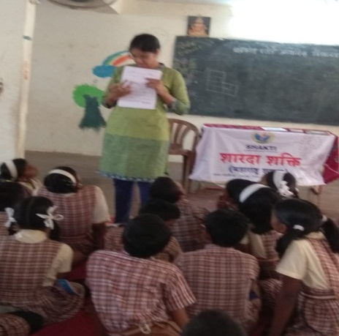 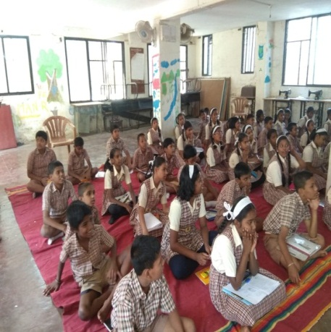 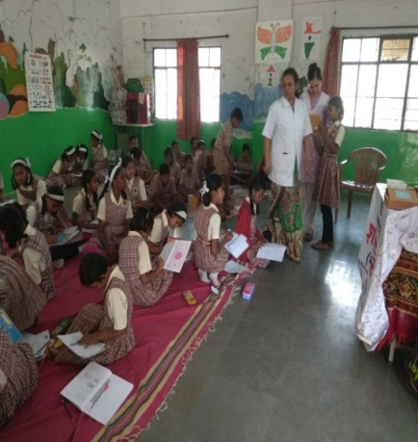

**Event name: Integrative session for** Self help group women in Kasaba Peth, on

**Maintaining good health in Spring**

**Organizers:** Sharada Shakti

**Speaker:** Dr. Leena Bavadekar

**Committe :** Simantini Vaze, Dr. Rajashree Kashalkar, Dr. Leena Bavadekar

**Date:** 10 April 2019

**Venue:** Pr. 16, kasaba Peth MNP. Shala No. 8, Pune

**No of attendees:** 40 Women

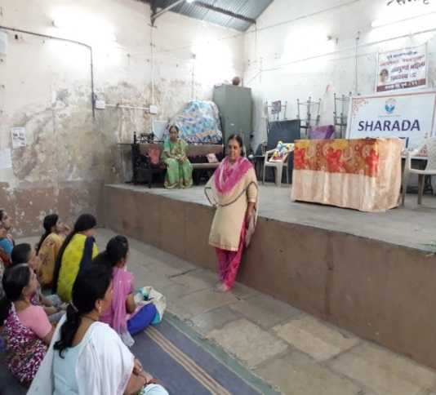 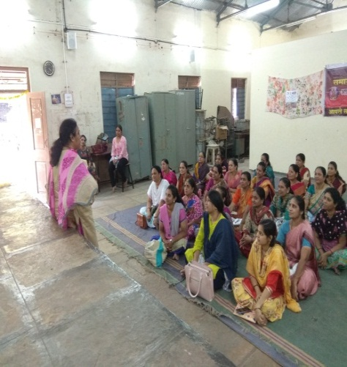

**Event name:** Mathematic workshop for **School Teacher**

**Introduction:** Sharada Shakti arranged mathematic workshop for Teachers.

This workshop was conducted by Prof. Gitanjali Phatak. She explained simple method for teaching the concept and formulae to the student.

**Organizers:** Sharada Shakti

**Speaker: Prof** Geetanjli Phatak, S. P. College Pune

**Committe:** Simantini Vaze, Dr. Rajashree Kashalkar

**Date:** 18 April 2019

**Venue:** Chandrakant Darode High School

**No of attendees:** 25 Teachers

**Impact including Outcome:** There was very good interaction between the participant and the speaker. All the participant exchanged their method of teaching concept and formulae with each other. The Participant gave a feedback that the workshop gave them new ideas about teaching concept and formulae in mathematic.

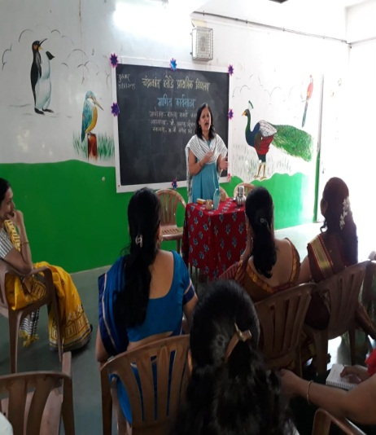 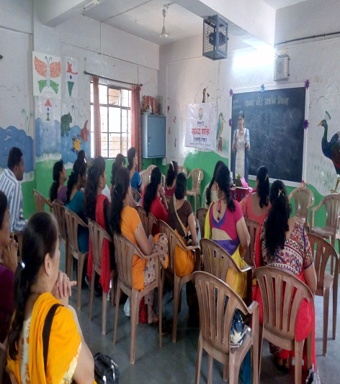 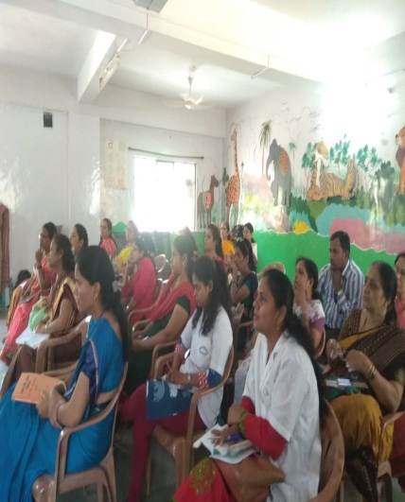

**Event name : Lecture** onVitamin B12 requirement for women

**Introduction:** Dr. Kirti Bhati conducted an interactive Session on, Vitamin B12 requirement for a human body, Defeciency of B12, it’s consequences and remedial measures. The audience was women from Kasaba Peth, self help group

**Organizers:** Sharada Shakti

**Speaker:** Dr. Kirti Bhati

**Committee:** Simantini Vaze, Dr. Rajshree Kashalkar, Dr. Priyamvada Herlekar

**Date :** 10 May 2019

**Venue:** Prabhag no. 16, Kasaba Peth, Municipal Shala No. 8, Pune

**No of attendees :** 45

**Impact including Outcome**: Women from Self help group were made aware of the need of Vitamin B12 and they realized the need for B12 supplements and pledged to take of themselves.

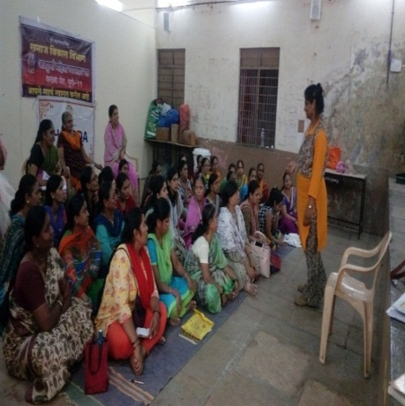 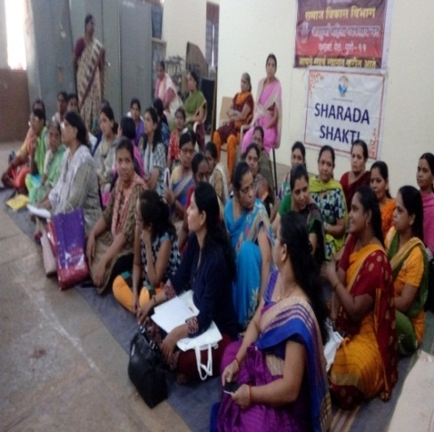

**Event name:** Environment day

**Introduction:** On the occasion of Environment day Sharada Shakti arranged lecture in Kasaba Peth Self help Group. Mrs. Manisha Kulkarni gave lecture and Power Point presentation on ‘ Jal hai to kal hai’ .

**Organizers:** Sharada Shakti

**Speaker :-** Mrs. Manisha Kulkarni

**Committee :** Mrs. Simantini Vaze, Dr. Rajashree Kashalkar, Dr. Priyamvada Herlekar, Dr. Leena Bavadekar, Mrs. Manisha Kulkarni, Mrs. Aruna Joshi

**Date :** 10 June 2019

**Venue:** Annapurna Vyavasaya Gat Pr. 16, Kasaba Peth Pune Corporation school No. 8

**No of attendees :** 35

**Impact including Outcome :** All women understood the important of saving water. They took a pledge that they will rescpt water use it carefully and always save water.

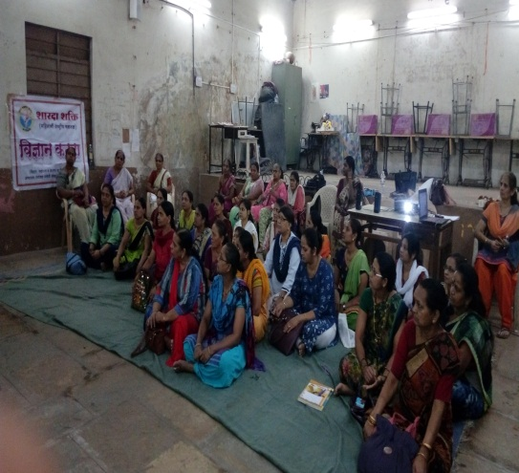 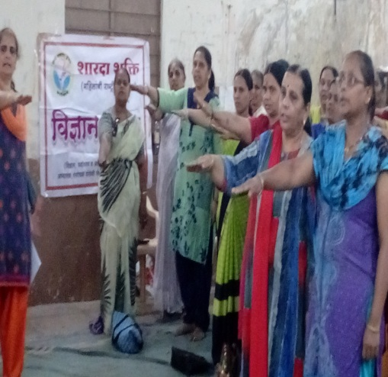

**Event name:** Environment day – ‘Jal hai to kal hai’ for Karyakarta of Bharatiya Majdur Sangh

**Introduction:** During this program discussion and Power Point Presentation were arranged by Sharada Shakti. Dr. Rajashree Kashalkar President of Sharada Shakti in short explained work of Sharada Shakti and introduced three speakers of this program. Presentation was Audio Visual.

1) Mrs. Simantini Vaze explained the following:- Importance of water, Water Resources on Earth, Reality about water needs and consumption use.

2) Mrs. Aruna Joshi elaborated that Although there in water present on Earth in should be pure to use for drinking and other use. How the water is purified? What is pure water?, and water foot Print? She explained why one cup of tea needs 35 liters of water.

3) Mrs. Manisha Kulkarni Explained about some projects run by The Government like. For eg. River Linkage Project, recycling water, water management etc. She also explained methods for conservation of water and its proper use. On personal level by giving example of 6 R. Israel almost a Dessert countries is exporting water to different country by good water management.

Mrs. Simantini Vaze conducted the program by giving many examples of importance water. From the Audience 3 / 4 people shared their views and experiences regarding their method of water conservation at management in their society.

Mrs. Simantini Vaze, delivered water saving oath to all.

Dr. Leena Bavadekar National Secretary of Shakti shared information about project and activities of Sharada Shakti organization.

Secretary, Bharatiya Majdur Sangh shri. Deshpande welcome everyone and told about their activates. President, Bharatiya Majdur Sangh Maharashtra State shri. Anna Dhumal expressed vote of thanks

**Organizers:** Sharada Shakti and Bharatiya Majdur Sangh

**Speaker:** Mrs. Simantini Vaze, Mrs. Aruna Joshi and Mrs. Manisha Kulkarni

**Committee:** Mrs. Simantini Vaze, Dr. Rajshree Kashalkar, Dr. Primvada Herlekar, Mrs. Manisha Kulkarni, Mrs. Aruna Joshi, and Dr. Leena Bavdekar

**Date :** 13 June 2019

**Venue:** Late Balasaheb Sathey Sabhagruha,– Bharatiya Majdur Sangh office

**No of attendees:** 50

**Impact including Outcome:** Karyakartas understood the important of saving water. They took a pledge that they will respect water use it carefully and always save water.

All Karyakartas were happy and stained. They decided to create awareness about importance of water conversation among different part of the society. They also requested Sharda Shakti to conduct difference program in collaboration with Bharatiya Majdur Sangh

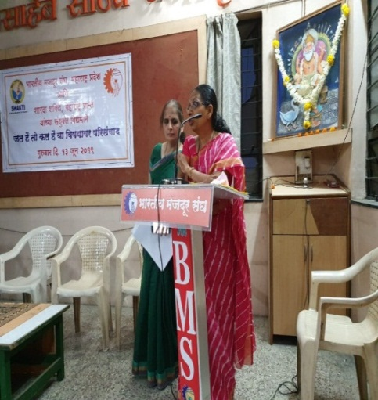 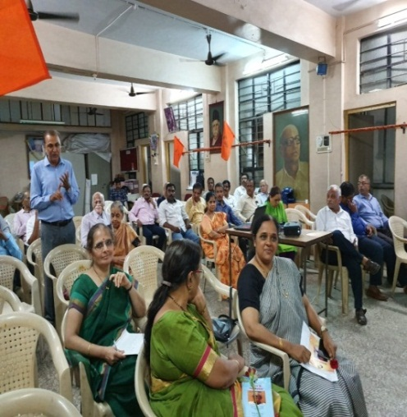

**Event name :** 5th International Yoga Day

**Introduction :** On the occasion of 5th International Yoga Day, Sharada Shakti invited Dr. Rajashree Gawade from B. K. S. Iyengar Institute, Pune for Yoga demonstration. Dr. Leena Bavadekar, Dr. Rajashree Kashalkar, Dr. Kirti Bhati, Dr. Manisha Khaladkar and Mrs. Neela Sahastarabudhe attended the Program. Principal Dr. Kharat participated and enhanced enthusiasm of all college faculties participated.

**Organizers :**  Sharada Shakti andP. E. Society’s Modern College of Arts, Science and Commerce, Ganeshkhind, Pune

**Speaker:** Dr. Rajashree Gawade (B. K. S. Iyengar Institute, Pune)

**Committee:** Dr. Rajshree Kashalkar, Dr. Leena Bavdekar, Dr. Kirti Bhati,

**Date:** 21 June 2019

**Venue:** P.E. Society’s Modern College of Arts Science and Commerce

**No of attendees:** 60

**Impact including Outcome:**

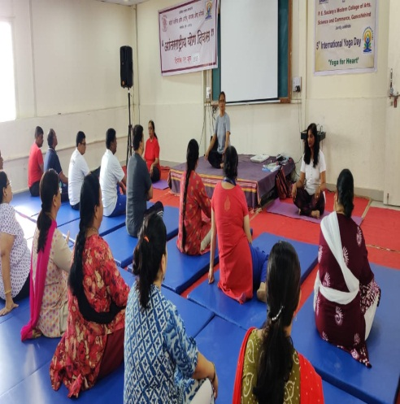 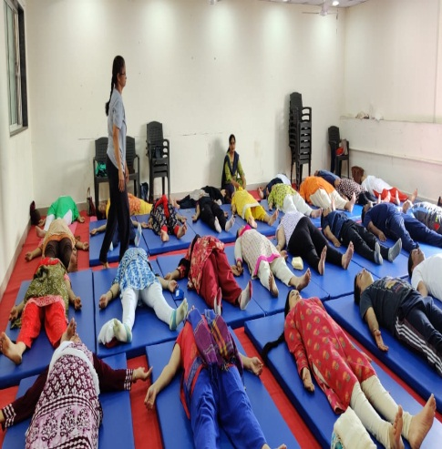

**Event name:** Digital Literacy awareness

**Introduction:** Sharda Shakti organized 'Digital Literacy' workshop for members of ‘'Abhaya' ‘support group for single women run by ‘Vanchit Vikas sanstha’.

Dr.Rajashree Kashalkar, Sharda Shakti President, gave information about the activities of Sharda Shakti. Sharda Shakti Treasurer, Simantini Vaze, introduced the speakers.

Professor Pallavi Joshi, PICT Engineering College, gave information about what 'Digital Literacy means and its need’. She introduced some Apps like Facebook, Bhim UPI on mobile.

Professor Sonali Jalukar of Deccan Institute of Commerce, gave demostation of using Ola Cab app. She also gave some important information regarding care to be taken while using the different Apps.

 Dr. Rajshri Kashalkar felicitated the speakers.

**Organizers:** Sharada Shakti

**Speaker:** Mrs. Pallavi Joshi, and Mrs. Sonali Jalukar

**Committee:** Mrs.Simantini Vaze, Dr. Rajashree Kashalkar, Dr. Leena Bavadekar, Mrs.Parinita Relekar

**Date :** 07 July 2019

**Venue:** Vanchit Vikas, Pune

**No of attendees :** 45 women

**Impact including Outcome:** A group of 10 women were interested To learn more about Digital Literacy. With the help of Prof. Sonali Jalukar. Another lecture on Digital Literacy was arranged for them.

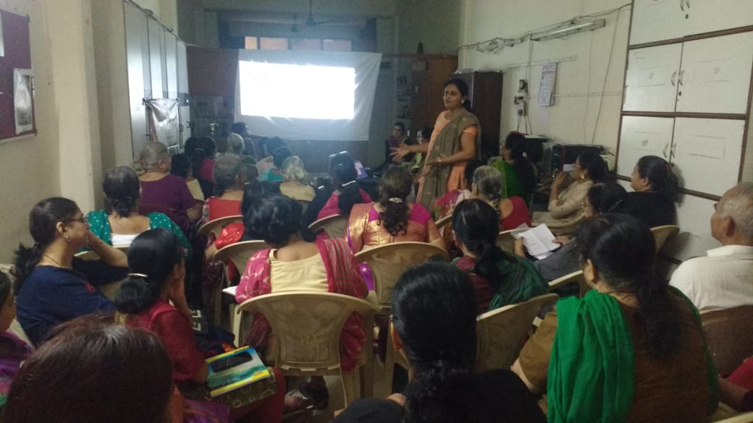 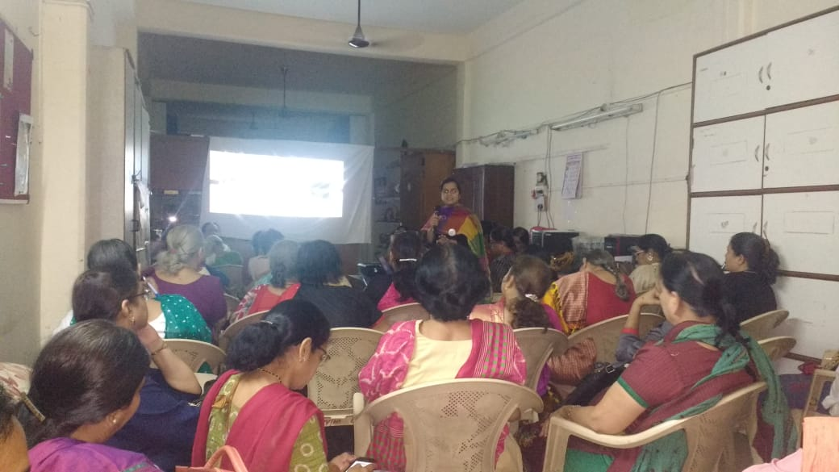

**Event name:** Environment day celebration Jal hai to kal hai

**Introduction:** During this program discussion and Power Point Presentation were arranged by Sharada Shakti for members of Samiti, Aparna Shakha Pdmavati, Pune. Dr. Rajashree Kashalkar President of Sharada Shakti in short explained work of Sharada Shakti and Mrs. Manisha Kulkarni introduced three speakers of this program. Audio Visual Presentation was Done. Speakers explained the aspects of water conservation, water water Resources, water footprint and government project.

1) Mrs. Simantini Vaze: Importance of water, Water Resources on Earth, Reality about water needs and consumption use.

2) Dr. Rajashree Kashalkar: Although there in water present on Earth in should be pure to use for drinking and other use. How the water is purified. What is pure water. And water foot Print. Eg. One cup of tea need 35 liters of water.

3) Mrs. Manisha Kulkarni Explained about some projects run by The Government like. For eg. River Linkage Project, Recycling water, water management etc. She also explained methods for conservation of water and its proper use. On personal level by giving example of 6 R. Israel almost a Dessert countries is exporting water to different country by good water management.

Mrs. Simantini Vaze, delivered water saving oath to all.

**Organizers:** Sharada Shakti

**Speaker:** Dr. RajshreeKashalkar Mrs. Simantini Vaze, and Mrs. Manisha Kulkarni

**Committee:** Mrs. Simantini Vaze, Dr. Rajshree Kashalkar, Mrs. Manisha Kulkarni,

**Date:** 11 July 2019

**Venue:** Aparna Shakha Pdmavati, Pune

**No of attendees:** 40 Women

**Impact including Outcome:** All women understood the important of saving water. They took a pledge that they will respect water use it carefully and always save water.

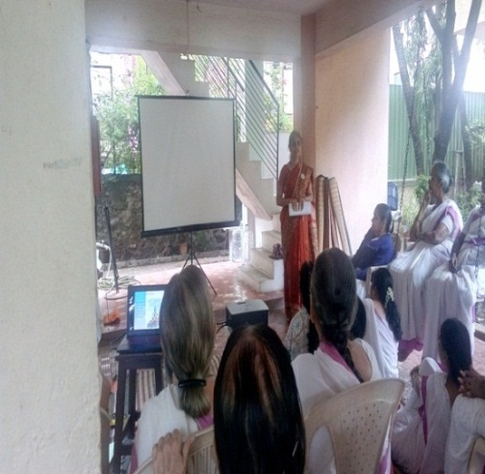 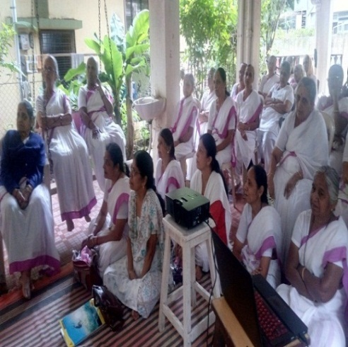

**Event name:** Vijanan Katta

**Introduction :** For Self help group women in Kasaba Peth, Mrs. Pradnya Giri delivered a talk on Adulteration of food. She gave lecture on how to identify Adulteration of food in the kitchen with the help of Power Point presentation.

**Organizers:** Sharada Shakti

**Speaker:-** Mrs. Pradnya Giri

**Committee:** Simantini Vaze, Dr. Rajashree Kashalkar

**Date:**10 July 2019

**Venue:** Kasaba Peth Self help group Pune

**No of attendees:** 80

**Impact including Outcome:** Awareness about food adulterationwas created among the participant. They said that they would be careful while buying food items.

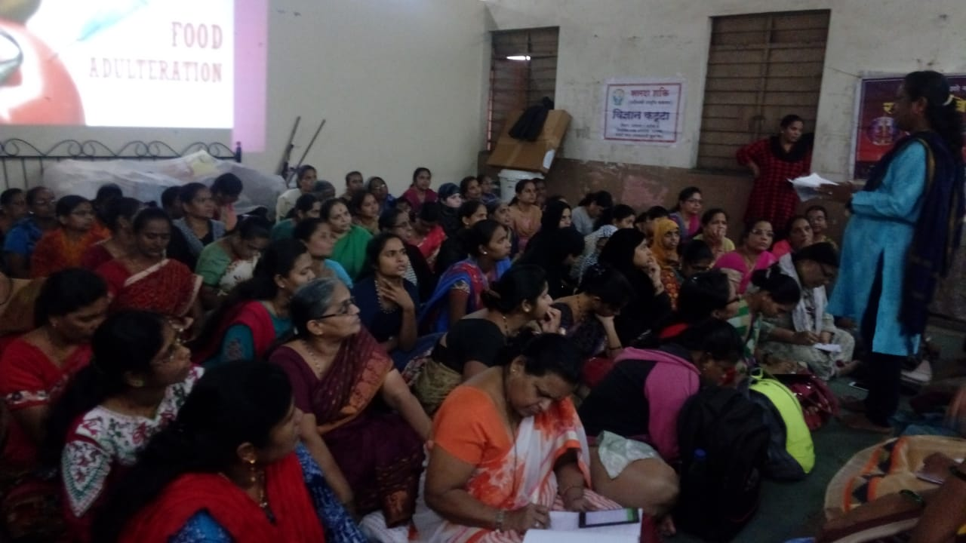 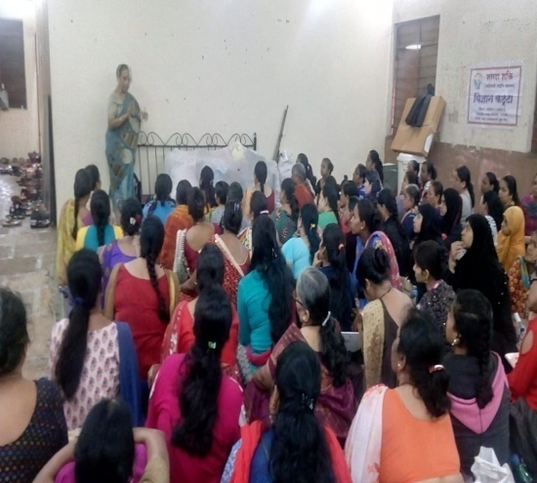

**Event name :** Abhyas Varga for Executive Committee Members

**Introduction:** Sharada Shakti conducted Abhyas Varga for Members of Executive Committee. The varga was conducted in 2 sessions.

Shri. Atulji Nagras discussed the subject of ‘Seva and Karyakarta.

Shri. Madavji Mate shared his thoughts on office and account work

**Organizers:** Sharada Shakti

**Speaker:** Shri. Atulji Nagras, (Founder Director, Seva Sahayog Foundation) and Charted account Shri. Madhavji Mate (Abhay Mate)

**Committee:** Simantini Vaze, Dr. Rajashree Kashalkar, Dr. Leena Bavadekar

**Date:** 20 Jully 2019

**Venue:** Sharada Shakti Office

**No of attendees:** 13

**Impact including Outcome:**

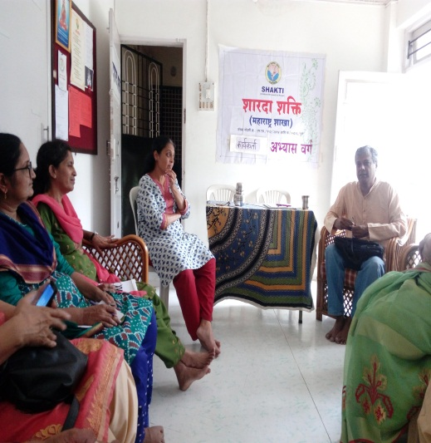 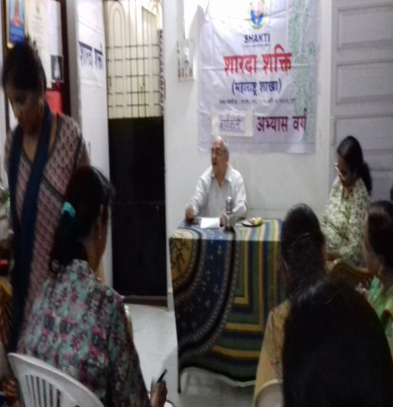

**Event name :** Workshop on Sustainable lifestyle

**Introduction:** Dr. Saurabh Jogalekar explained the topic “Sustainability” in a very simple language and effectively through the presentation, video films, discussions and group activities. He explained the need for sustainability and the problems like global warming, extreme weather conditions etc.

He discussed with the students about the life cycle stages, which stage contributes more for higher GHG emission.

He demonstrated the calculation of life cycle assessment; he explained midpoint and end point indicators for LCA calculations, LCA framework Ecological footprint and Water footprint. With the help of activity to calculate their personal carbon footprint. Depending on the yearly Carbon footprint, how much trees should be planted was also calculated.

Dr. Swati Jogalekar, Vice Principal, Fergusson College , delivered introductory speech. Dr. Rajashree Kashalakar, president Sharada Shakti, briefed about the activities of Sharada Shakti and urged students to join the hands with Sharada Shakti. The staff of Department of environmental science and HOD, Prof. Rupali Gaikwad were present for the program.

**Organizers:** Sharada Shakti and Fergusson College

**Speaker:** Dr. Saurabh Jogalekar, Assist. Prof. Dept of Chemical Engineering, Laxminarayan Institute of Technology, Nagpur

**Committee :** Dr. Rajashree Kashalkar, Dr. Leena Bavadekar, Mrs. Manisha Kulkarni, Dr. Manisha Khaldakar, Prof. Swati Jogalekar, Prof. Rupali Gaikwad

**Date:** 2 August 2019, Time 10am. to 2.00pm.

**Venue:** Fergusson College

Bottom of Form

**No of attendees:** 65 students (U.G. and P.G.) and the staff of department of environmental science of Fergusson College

**Impact including Outcome: T**he students were made aware about the term “Sustainability” and the importance of Sustainable lifestyle. To achieve this, Dr. Jogalekar emphasized on formulation of problem and System thinking.

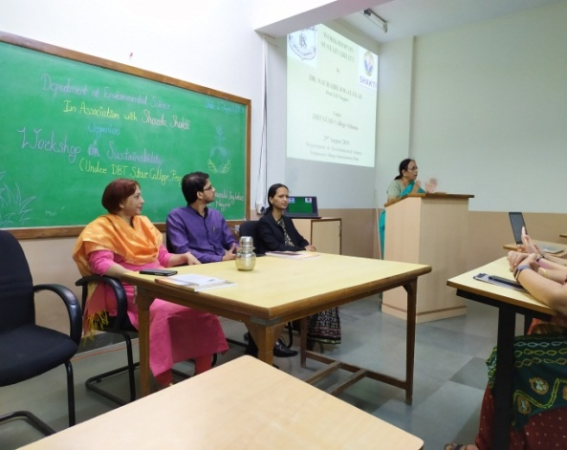 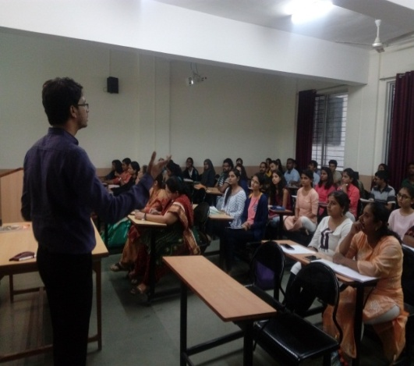

**Event name:** Sustainability Workshop

**Introduction:** Dr. Saurabh Jogalekar explained “Sustainability” topic very easily and effectively through the presentation, video films, discussions and group activities.

He explained the need for sustainability. If we do not follow the sustainable life style then in coming days, we are going to face the problems like global warming, extreme weather conditions etc.

He discussed with the students about the life cycle stages, which stage contributes more for higher GHG emission.

The students were given the activity to calculate their personal carbon footprint. Depending on the yearly Carbon footprint, how much trees should be planted was also calculated.

Dr. Jogalekar also explained the terms, Ecological footprint and Water footprint.

At SP Collage, Dr. Rajashree Kashalkar, president briefed about the activities of Sharada Shakti and urged students to join the hands with them. Dr.Dilip Sheth , Principal, S.P. college, enlightened the students about continuous learning and what they have learnt in the workshop they should start applying in day to day life. Vice Principal, Dr. Diwade and Dr. Sunil Kulkarni, Incharge EVS were present for the program.

**Organizers:** Sharada Shakti

**Speaker:** Dr. Saurabh Jogalekar, Assist. Prof. Dept of Chemical Engineering, Laxminarayan Institute of Technology, Nagpur

**Committee :**Dr. Leena Bavadekar, Dr. Rajashree Kashalkar, Dr. Priyamvada Herlekar,

Mrs. Manisha Kulkarni,

**Date :** 3.8.2019

**Time** 10.00 am to 2.00 am

**Venue:** A.V. Hall Sir Parshurambhau College, Pune

**No of attendees:** S.P. College – Science faculty students 70(U.G.)

**Impact including outcome:** The students were made aware about the term “Sustainability” and the importance of Sustainable lifestyle. To achieve this, Dr. Jogalekar emphasized on formulation of problem and System thinking.

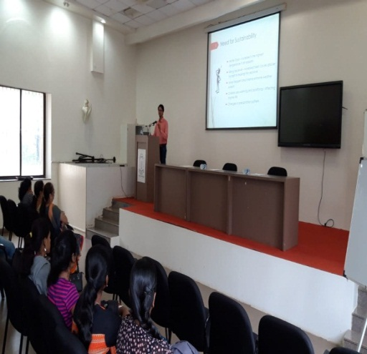 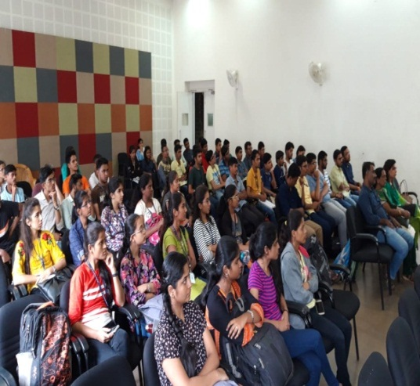

**Event name :** Eco friendly Ganesh Idol Making workshops

**Introduction:** In view of approaching Ganesh festival plaster of paris, organic paints, thermocol, platics are used on large scale for making the Ganesh idols and for decoration which cause pollution. To reduce load of such pollutents in environment eco friendly Ganesh idols and decoration from spent household material was used for the workshop. On 3 consequtive weekends in August these workshops were conducted. 45 students attended the workshop, Mrs. Simantini Vaze, Dr. Rajashree Kashalkar, Dr. Priyamvada Herlekar, Mrs. Nayana Bhurke, Mrs. Parinita Relekar Mrs. Dhanashree Tekale conducted the workshops. Mrs Preeti Nayakawadi conducted the decoration workshop.

**Organizers:** Sharada Shakti

**Resource Person:** Omkar Surve, Dnyanesh Yallariche

**Committee:** Dr. Rajashree Kashalkar, Dr. Leena Bavadekar, Dr. Priyamvada Herlekar , Mrs. Simantini Vaze, Mrs. Nayana Bhurke

**Date :** 4, 11, 18 August 2019,

**Venue:** Annapurna Vyasaya Gat, Prabhag No. 16, Kasaba Peth, Pune

**No of attendees :** 121

**Impact including Outcome**: Reduction in water pollution and land pollution.Children was very happy and enjoy making Ganesh Murti.

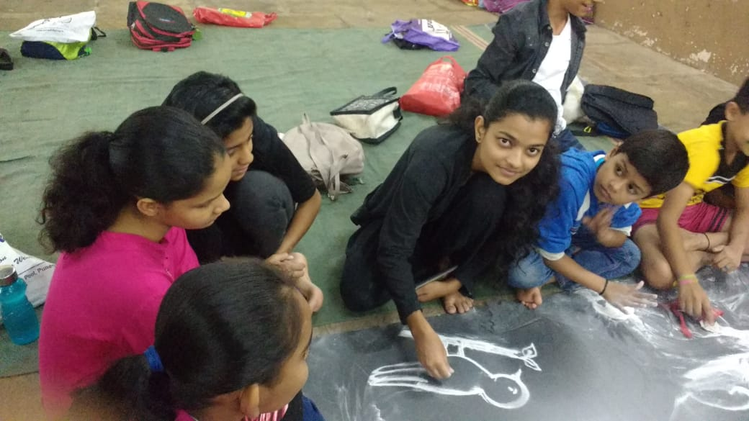 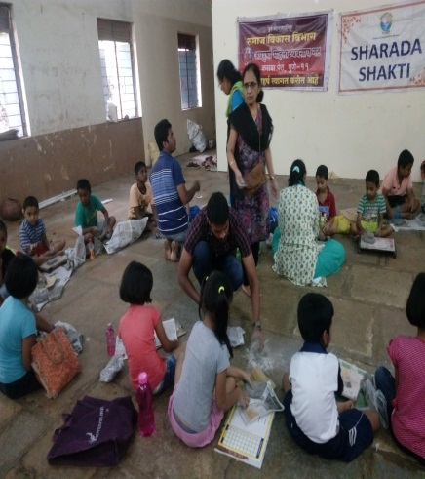 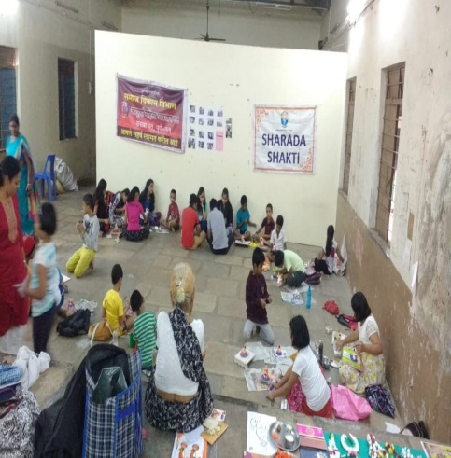

**Event name :** Sharda Shakti team to check the health check up of flood-relief Punekars by Sharada Shakti team

**Introduction:** It rained more than average this year. Western Maharashtra was in water. In Pune too, 5-6 bridges were closed due to floods. At around 3 am, water suddenly flooded some settlements between Vishrantwadi, Indira Nagar, Hanuman Mandir, Shanti Nagar and many families were shifted to nearby schools.

Sharada Shakti took the initiative of health check up of these families. Health camp was held on 9th August 2019 in all the above three settlements. A team of about 7-8 doctor members worked from 11 am to 5 pm. About 450-500 people were examined.

President of Sharda Shakti Dr. Rajashree Kashalkar, Dr. Priyanvada Herlekar, National Secretary Dr. Leena Bawdekar caste were present and they were instrumental in the investigation.

**Organizers:** Sharada Shakti

**Committee:** Dr. Rajashree Kashalkar, Dr. Leena Bavadekar, Dr. Priyamvada Herlekar

**Date:** 9 August 2019

**Venue:** Vishrantwadi, Indira Nagar, Hanuman Mandir, Shanti Nagar

**No of attendees:** 450-500 people

**Impact including Outcome:** Health check up of flood affected people helped to understand their problem. They work explained how they should take care about the health problems arising you to their stay in flood affected area. Medicine was distributed to them.

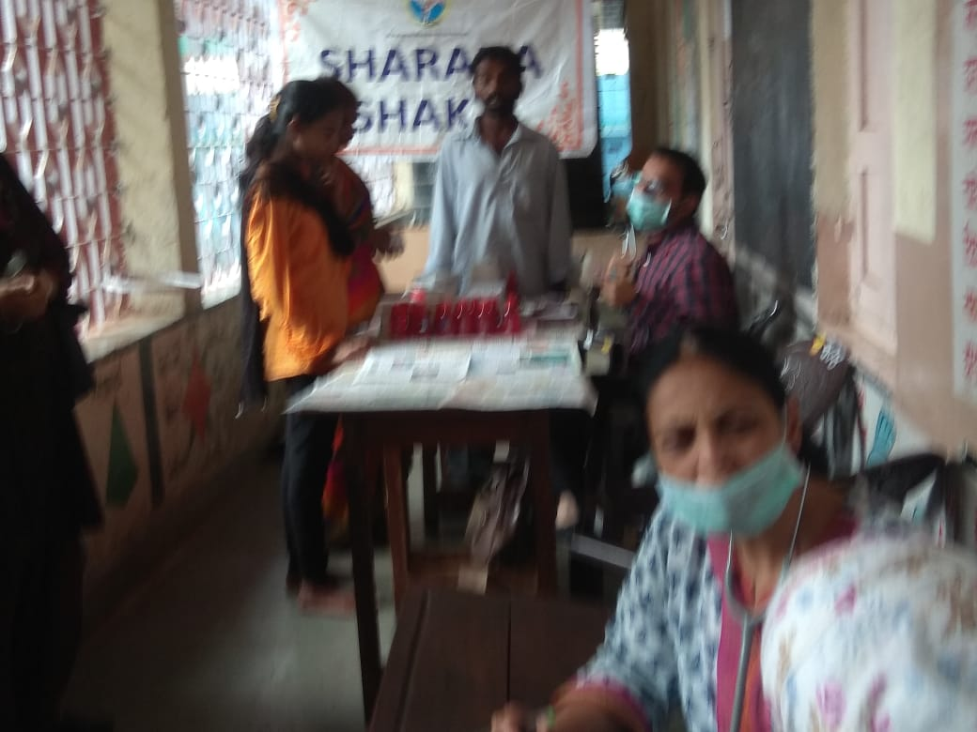 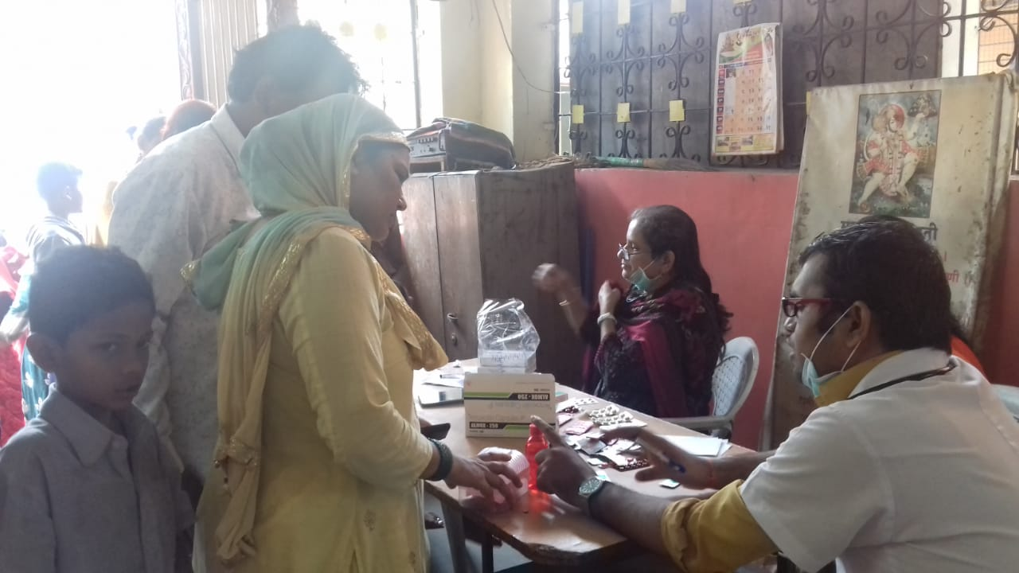

**Event name:** Akhand Bharat Sankalp Din and Rakshabandhan

**Introduction:** On 14th August 2019, Swami ShraddhanandShakha, GhorpadiPeth, Pune, celebrated Akhand Bharat Sankalp Din and Rakshabandhan. Mrs. Seemantini Vaze talked about the role of Sharda Shakti, Rakshabandhan and how to celebrate Eco friendly Ganeshotsav.

**Organizers:** Sharada Shakti and Utkarsh Mahila Mandal

**Speaker:** Mrs. Simantini Vaze

**Committee:** Simantini Vaze, Dr. Rajashree Kashalkar, Dhanashri Tekale

**Date:**14 August 2019

**Venue:** Swami Shraddhanand Shakha, Ghorpadi Peth, Pune,

**No of attendees:** 50 boys and 15 karykrte

**Impact including Outcome:** Akhand Bharat Sankalp Din was celebrated in full excitement. Children was very happy and enjoy Rakshabandhan

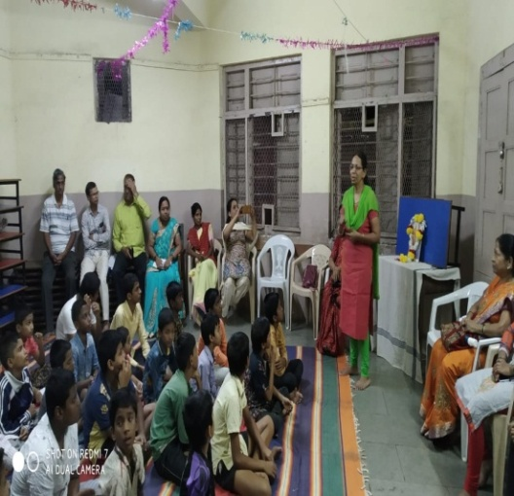 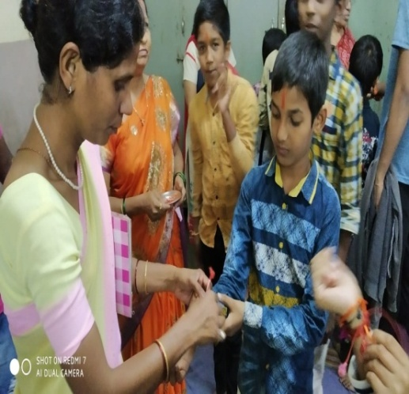

**Event name :** Digital literacy Workshop

**Introduction**: A digital literacy and mobile apps using workshop was conducted for members of Vanchit Vikas sanstha by Mrs. Sonali Jalukar.

**Organizers:** Sharada Shakti

**Speaker:-** Mrs. Sonali Jalukar

**Committee:** Simantini Vaze, Dr. Rajshree Kashalkar, Dr. Leena Bavadekar

**Date:** 20 and 21 August 2019

**Venue:** Deccan institute Kasaba Peth, Pune

**No of attendees:** 20

**Impact including Outcome:** Members ofvanchit vikas were able to use cell phones effectively for digital transactions.

**Event name :** Health checkup Camps

**Introduction:** Medical camp was organized for students of Hari Bhau Balwant Grime Highschool. Check up of General health, Dental check up, Eye check up and Hb% of all students from std 5 th to10th was done. The camp was organized by SharadaShakti jointly with Eaton India foundation. 25 volunteers from, Tilak Ayurved College, Bharati College of Ophthalmology, Rangunwala Dental College participated. The camp was supported by Sai Pathology Lab . Members of Sharada Shakti Dr. Priyamvada Herlekar Dr. Manasi Deshpande, Dr. Rajashree Kashalkar, Simantini Vaze participated in the camp .

**Organizers:** Sharada Shakti and 10 volunteers from Eaton India Foundation participated to make the workshop successful.

**Committee:** Simantini Vaze, Dr. Rajashree Kashalkar, Dr. Priyamvada Herlekar

**Date:** 21 Sept. 2019, and 28 Sept.2019

**Time:** 7.30 am to 2.30 pm

**Venue:** Hari Bhau Balwant Grime Highschool

**No of attendees:** 449

**Impact including Outcome:** For all students Hb% Check up, general health, eyes and dental check up was done.

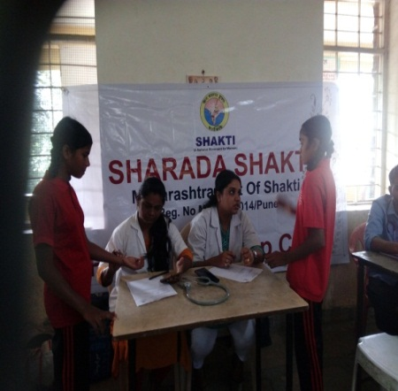 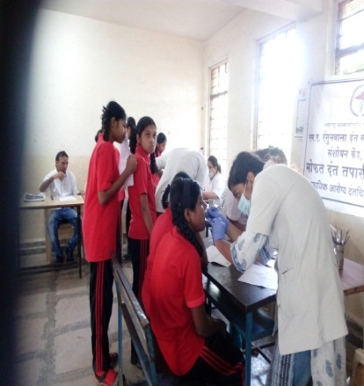

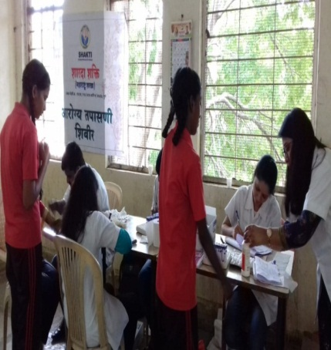 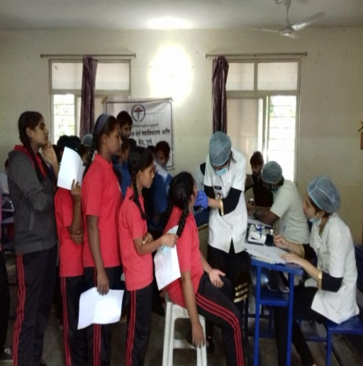

**Event name:** Vijanan Katta

**Introduction:** Lectures was organized on the topic of ‘Health is Wealth’ for under graduate students.

**Organizers:** Sharada Shakti

**Speaker:** Dr. Leena Bavadekar

**Committee:** Dr. Rajashree Kashalkar, Dr. Leena Bavadekar

**Date:**7 October2019

**Venue:** Shri Sidhivinayak Women College, Karve Nagar, Pune

**No of attendees:** 75 students and staff

**Impact including Outcome:** The girl students understood the importance of good health exercise and how to care for it. Dr. Bavadekar stressed the importance of proper diet even while staying at home, attending early practicals. Many doubts of the girls and the staff regarding health issues were cleared by Dr. Bavadekar.

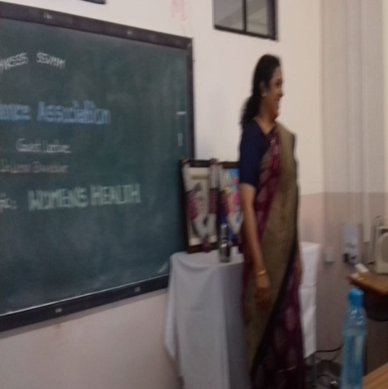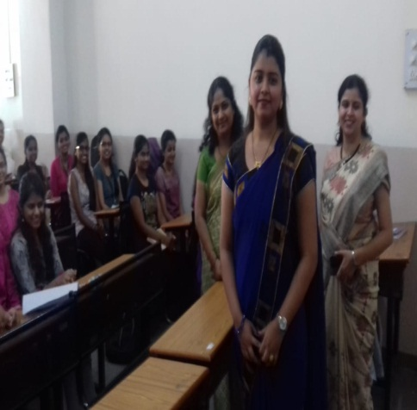

**Event name :** Bhagini Nivedita Kirtan

**Introduction:** The program of kirtan was presented by 'Sharda Shakti' with the aim of bringing the ignorant aspects of Bhagini Nivedita's dedication and scientific contribution to the society through kirtan and inspiring the younger generation through her work. Bhagini Nivedita’s life, social work and contribution to scientific community by was displayed through an ancient folk art form called Kirtan was performed by Mrs. Rupali Sathe. Kirtan is a form of storytelling. In which storytelling is a beautiful combination of music and drama. This is the first kirtan to the life of Bhagini Nivedita.

**Organizers:** Sharada Shakti

**Speaker:** Mrs. Rupali Sathe

**Committee:** Dr. Leena Bavdekar, Mrs. Simantini Vaze, Dr. Rajshree Kashalkar, Dr. Priyamvada Herlekar

**Date:** 13 Oct. 2019

**Venue:** Bharatiya Vichar Sadhana Santhecha Hall

**No of attendees:** 55

**Impact including Outcome :** A rare art of Kirtan and a rare work by Bhagini Nivedita was unfold before the audience.

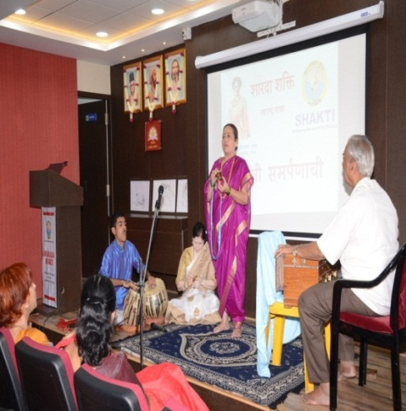 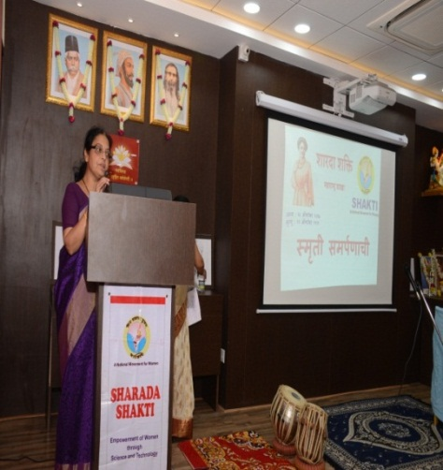

**Event name:** Vijanan Katta

Introduction: In women’s hostel there is a lot of wastage of water, girls need to be made of the consequences of such misuse of a valuable resource. In view of this a program on water conservation ‘Jal hai to Kal hai was conducted for hostel inmates of Rachana girls hostel, Panshet.

Mrs. Vandana Kulkarnigave lecture and Power Point presentation on Jal hai to kal hai!

**Organizers:** Sharada Shakti

**Speaker :-** Mrs. Vandana Kulkarni,

**Committee :** Dr. Rajshree Kashalkar, Dr. Primvada Herlekar, Mrs. Vandana Kulkarni,

**Date :** 19 October 2019

**Venue:** Rachana Hostel

**No of attendees:** 56

**Impact including Outcome:** Girls became awakened about the dire consequences of water wastage and committed to make proper use of the resource.

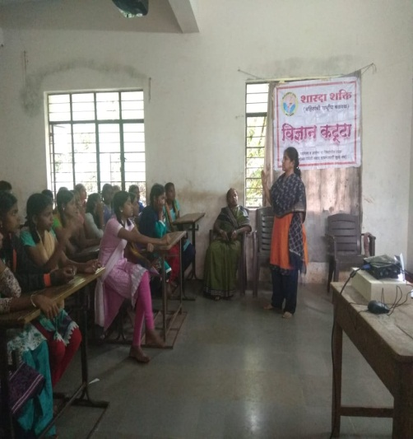 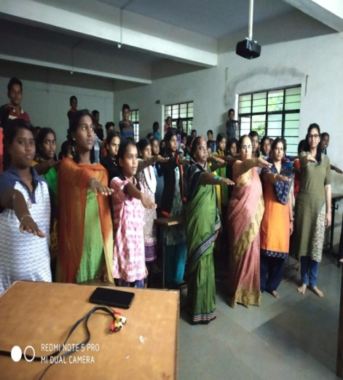

**Event name :**Heathy and tasty Dishes preparation competition for medical students.

**Introduction**: Heathy and tasty food preparation competition was conducted at Ashtang Ayurveda college for their students where Green gram, Bottle guard, Sesame, fenugreek, corn, palak were to be used as key ingredients. The judges were Dr M H Paranjape, Sunil Bahirat, DrGaikwad, DrKirtiBhati along with SharadaShakti executive members.

**Organizers:**Sharada Shakti and Ashtang Ayurved College

**Judges:** Dr.Kirti Bhati

**Committee:** Dr. RajashreeKashalkar, Dr. LeenaBavadekar, Dr. KirtiBhati

**Date:** 19 November 2019

**Time :** 11.00 am to 1.00 pm

**Venue:** AshtangAyurved College

**No of attendees:** 60

**Impact including Outcome:** The Students of Ayurved studying in the 1st,2nd,3rd year of BAMS came up with Novel, healthy recipes following the nutrition principles of Ayurveda.

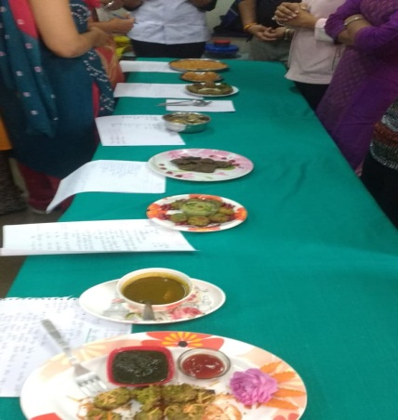 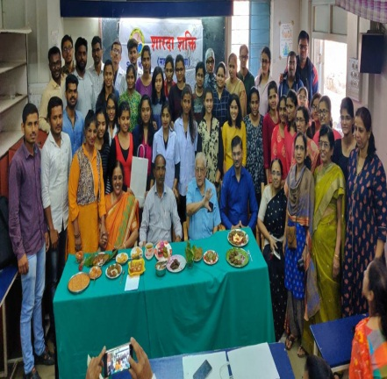 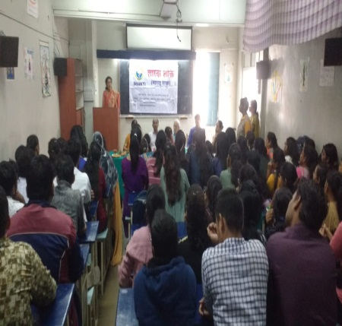

**Event name:** 6th State level Abhyas Varga

**Introduction:** State level AbhyasVargaof Sharada Shakti was conducted on 5th Jan 2020 at Ranade Balak Mandir School Pune. 28 Participants from Pune, Nasik and Sambhajinagar were present.

The program started with Prarthana. Sharada Shakti President Dr.RajashreeKashalkar welcomed the guests. She gave an account of common programs conducted at all Shakti units and annual program review for Sharada Shakti.

**Aim**

The main aim of this varg was to familiarize all members with Aims and objectives, key work areas, methodology of work done by Sharada Shakti. so that the members get an idea about how to work in the organization.,why should we have surveys?A brain storming on the role women in sustainable development would motivate the members to think and come up with original ideas regarding sustainable life styles.

For familiarizing new and old members and exchange of ideas and ideology of Shakti, significance of skill development and capacity building among members to develop and understand what is means to be a social worker.

**Organizers:** Sharada Shakti

**Speakers : Sri. JayantraoSahasrabudhe**(National Organization Secretary, Vijanan Bharati), **Dr. Leena Bavadekar** (National Secretary Shakti, Co-ordinator, Sharada Shakti) **Shri. Maheshji Karpe** (Pune Mahanagar Karyvahak, R.S.S.), **Dr Anjali Deshpande (Secretary, Drushti),**

**Committee:** Mrs.SimantiniVaze, Dr. RajashreeKashalkar, Dr. Priyamvada Herlekar,

Dr. Leena Bavadekar

**Date :** 5 Jan. 2020

**Venue:** Ranade Balak Mandir School Pune

**No of attendees:** 28

**Impact including Outcome :** National Shakti Co-ordinator **Dr.Leena Bavadekar** explained what is abhyasVarga, why it is necessary to have such abhyasvargas periodically.

**Shri Maheshji Karpe** guided the participants on how to strengthen the relations amongst the members of Shakti and also with other people in the society.

**Dr Anjali Deshpande** elaborated on the methods and importance of surveys in social sciences.She explained the journey of Drishti in making the All India Survey on **Status of Women in** **India** a great success.This gave numerous insights to the participants.

**Sri. Jayantrao Sahasrabudhe** conducted the brain storming session on, **Role of women in** **sustainable development** he also gave valuable inputs to channelize the thought process of the participants on the subject**.**

During the day there were interactions between all participants. They understood the ideology of Shakti, significance of skill development and capacity building among members to develop and understand what is means to be a social worker.

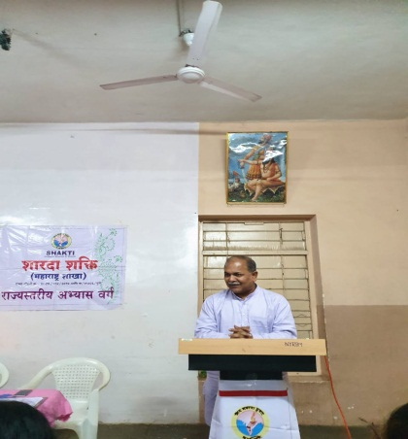 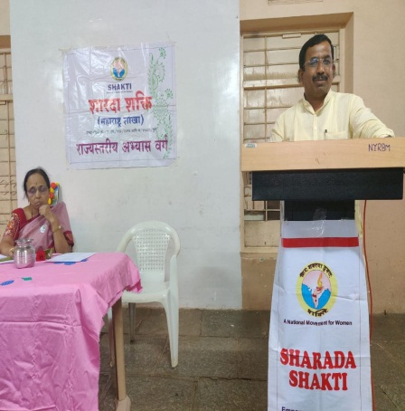 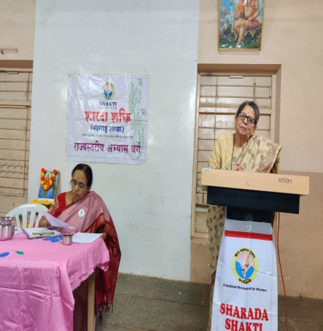

**Event name:** Science Day Celebration

**Introduction:** Science day celebrations at MKSSS girls college. As a part of Science day celebration activity a panel discussion was organized on **Sustainable** **life style**, ,followed by lecture on **Concept of commercialization of sustainable products** .

**Organizers:** Sharada Shakti and MKSSS' Sidhivinayak Women College

**Panelists**: Mrs. Vandana Kulkarni, Mrs. Mrudul Shirgurkar, Mrs. Simantini Vaze,

Prof. Ujwala Mate.

**Speaker:** Dr. Asmita Prabhune,

**Committee:** Dr. Rajashree Kashalkar, Dr. Primvada Herlekar, Mrs. Vandana Kulkarni,

Mrs. Simantini Vaze

**Date :** 27 feb. 2020

Time: 11.00 am To 1.00 pm

**Venue:** MKSSS' Sidhivinayak Women College Karvenagar Pune 411051

**No of attendees:** 85

**Impact including Outcome:**The Panel discussion gave insights to the attendies regarding how to reduce pollution in Laboratories, Doing Organic gardening on the terrace and important information about solar and wind energy**.**

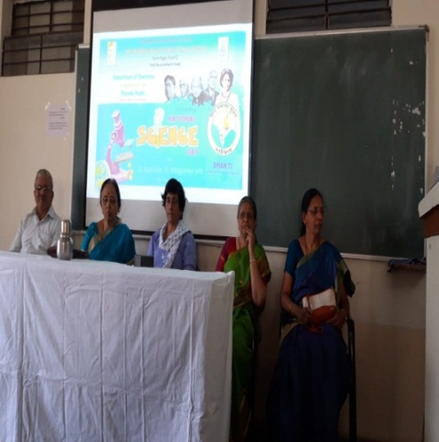 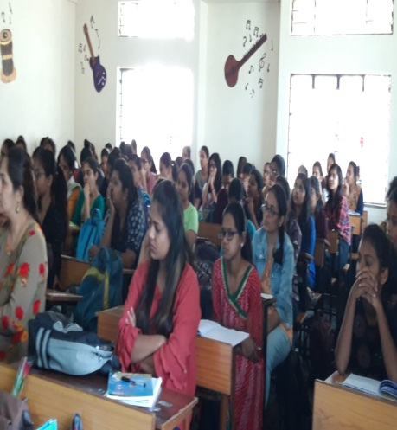

**Event name :**Health Check up Camp

**Introduction:** Medical camp was organized at Rabindranath Tagore English Medium School. Doctors from Tilak Ayurved College, Bharati College of Ophthalmology, Rangunwala Dental College. Health checkup of 250 primary school students was done.Dental and Eye check of all students was also done. The camp was arranged in collaboration with Eton India Foundation. Almost 8-10 volunteers from Eton foundation were present. Sharada Shakti members Dr. Rajashree Kashalkar, Dr. Priyamvada Herlekar Dr. Prajakta Anugde and Mrs. Dhanashree Tekale participated the Programme.

**Organizers:**Sharada Shakti and Eaton India Foundation

**Committee :** Dr. Rajashree Kashalkar, Dr. Priyamvada Herlekar

**Date :** 3 March 2020

**Venue:** Rabindranath Tagore English Medium School

**No of attendees:** 250 Students

**Impact including Outcome:** New members got connected to this activity **.**Awareness about oral health was explained to the students.

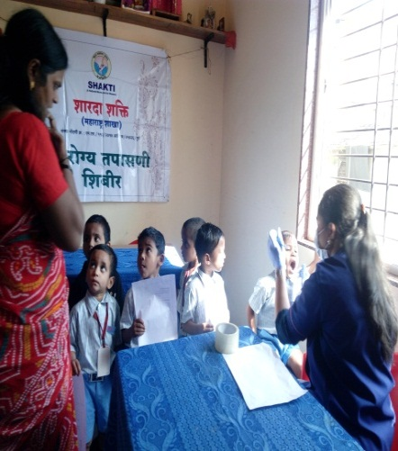 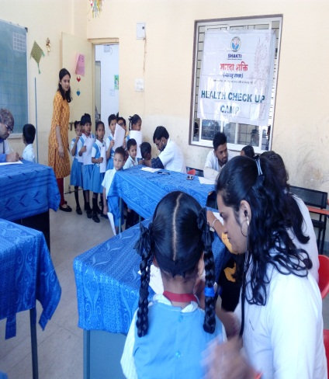 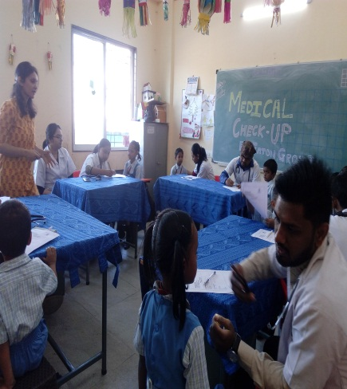

**Event name:** Lecture – Woman Empowerment

**Introduction:** As a part of Women’s day celebration an interactive session on Women empowerment was conducted at AshtangAyurved College Pune,

**Organizers:** Sharada Shakti and Ashtang Ayurved College

**Speaker:** Dr. Leena Bavadekar

**Committee:** Dr. Leena Bavadekar

**Date:** 6 March 2020

**Venue:** Ashtang Ayurved College

**No of attendees:** 45

**Impact including Outcome:** Students understood the importance of self empowerment **.**

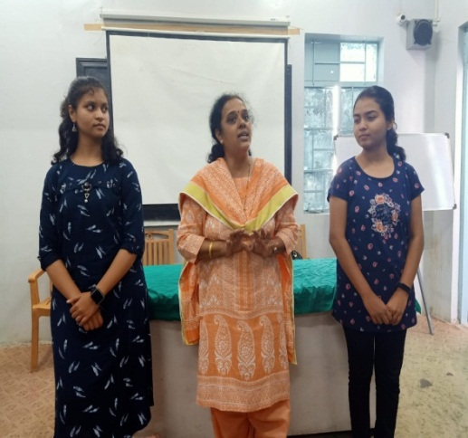 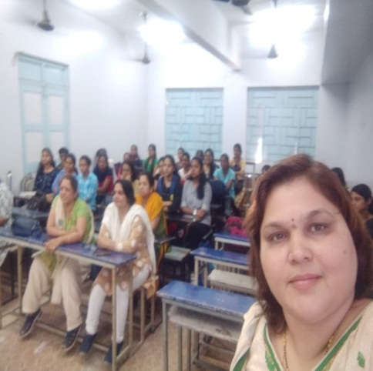

**Event name:** Women’s day celebration

**Introduction:** 40 after nd lifeHealth a Women

**Organizers:** Sharada Shakti

**Speaker :-** Dr. Leena Bavadekar and Dr.Ujwala Deshmukh

**Committee:** Prof.Swati Joglekar, Dr. Rajashree Kashalkar, Dr. Primvada Herlekar

**Date :**7 March 2020

**Venue:** Fergusson College, Pune.

**No of attendees :** 47Lady Professors.

**Impact including Outcome: Dr. Bavadekar** being an expert in Ayurveda explained the importance and various aspects of dincharya and nutrition for good health.

**Dr. Deshmukh** a Gynecologist, elaborated on the various tests& their importance which should be done after the age of 40 .she also elaborated on the care to be taken for maintaining good health after 40.bothe speakers answered the numerous questions asked by the participants.

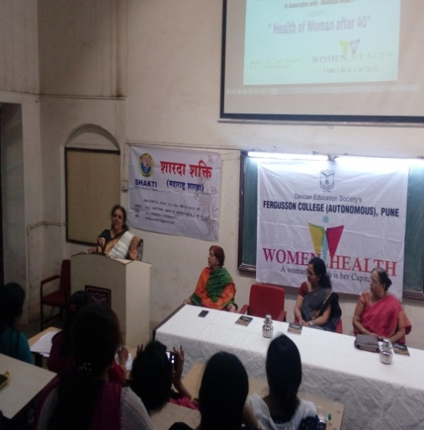 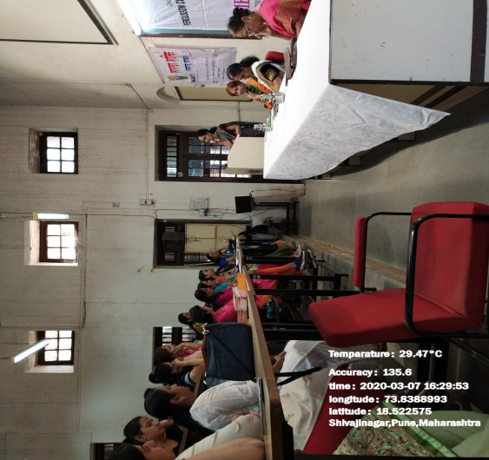

**Shakti Sthapana Divas 2020**

Shakti Sthapana Divas celebrations were planned on 21st March 2020 from 5.00 pm to 7.00 pm at Ganesh Hall, M. S. Golwalkar and New English School Tilak Road, Pune 411030.

**The four recipients of Shakti Prerana puraskar were :**

**Swa Shakti Prerna Purskar**

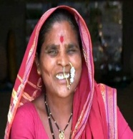

**Padamshri Mrs. Rahibai Soma Popare (Seed mother)**(बीजमाता)

Known all over the world as ' Seed mother ', she has saved about 53 crops and 116 Gavaran varieties with the help of BAIF and are promoting it through their Seed Bank.

Taking note of the work of the nuns, she was awarded the highest Civilian honor for women in India 'Nari Shakti' in 2018 by the Department of Women and Child Welfare ,Government of India at the hands of Hon'ble President Ramnath Kovind.  
She is among three Indians on BBC list of “100 Women 2018” in the world. The short film 'Seed Mother' based on a nun has won the third place at the 2019 Cannes Film Festival in France. Apart from this, she has been honored with many honors like "Jijamata Krishi Bhushan Sanman, Vasantrao Naik Sanman, Ananya Sanman, Krishiratna" given by the Department of Agriculture.This year she has been awarded Padmashri by the Government of India.



**Mrs. Mamatabai Devaram Bhangare (Foodmother) (अन्नमाता)**

Mamtabai is known as ‘Food Mother’. she has represented the state of Maharashtra in the International Science Festival held in Calcutta in 2019. She has taken the organic farming movement to the country and abroad. Mamatabai's experiments in organic farming are a guide to paddy farming and various crops. She has guided thousands of tribal women and farmers so far.

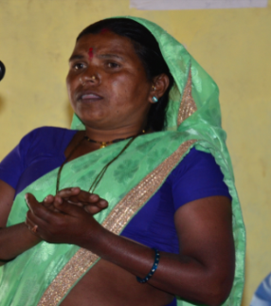

**Mrs. Sonabai Vitthal Bhangare (water experts) (जलतज्ञ)**

With the help of BAIF, Sonabai has given impetus to the development of agriculture in the tribal areas through various works such as diversion dams, wells, uptake, irrigation, spring development.   
However, the diversion dam built by her at a cost of ten thousand rupees has become a topic of much discussion. The water use skills she studied in the school of nature are unprecedented. That is why they are called 'water experts' in rural areas.

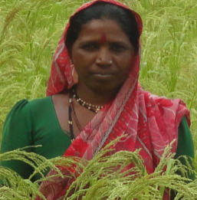

**Mrs. Hirabai Haibat Bhangare (Dhanmitra) (धानमित्र)**

With her studious and hardworking attitude, Hirabai has saved about sixteen native rice varieties from extinction. She has been distributing these traditional varieties to thousands of farmers for the last seven to eight years by setting up a seed bank at her residence. Their Rice Variety Research Center is providing new direction and sustainability to paddy farming. Paddy is the main crop of thousands of tribals. Hirabai, who strives for her eternity, is known in this area as 'Dhanmata'.

**Swa Shakti Samman Purskar**

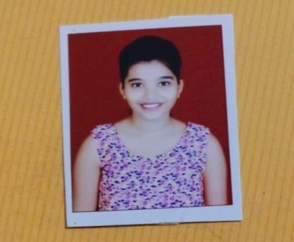 **Varsha Bhagat**

Varsha Bhagat is pursuing M. Sc. (Biochemistry) from Ferguson College Pune.