DETAILED REPORT OF THE E-VARG EVENT
DAY 1
TITLE: A SPECIAL BAUDHIK VAKTAVYA by Dr. Annapurna Acharya
DATE: 3/6/2020
The first day of the Shakti E-VargAbhyas started with singing of the Varg song sung by the Shakti members and thereby was followed by lecture delivered by our respected guest Dr. Annapurna Acharya jee who explained the gist of Holy Bhagvad Gita invery simplified words. The lecture delivered by her also focussed on the Krishna- Arjun Interaction during the Mahabharata war, how Gita is a way of living life irrespective of which religion we belong to and Lord Krishna teachings and his assurance to the world that he will always be there whenever religion will be attacked by someone. After a spellbound and enlightening lecture, there were E games held by the Shakti members. The first day came to an end with the Shanti Mantra and a thank you note to all.
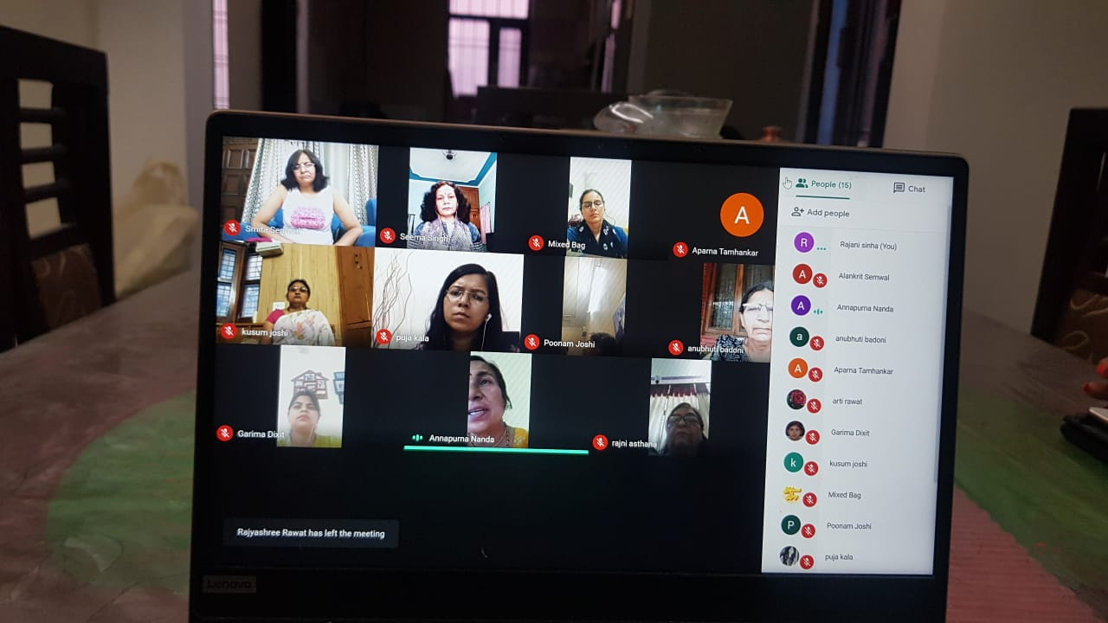
DAY 2
TITLE: Aromatherapy
DATE:4/6/2020

The second day of the Shakti E VargAbhyas started with the singing of Varg song sung by the Shakti members and thereby followed by a lecture on Aromatherapy delivered by Dr. Jyoti Marwah. The first day of Shakti E Varg comprised of a lecture on way of living whereas the second day involved teachings on a healthy way of living life. Dr. Jyoti focussed her lecture on a preliminary introduction to the basics of Aromatherapy or Gandhashastra and also on healthy ways of living such as yoga, meditation, Confidence, positivity, Nature- healing, how aroma of flowers, earth etc helps us to heel, Touch and heel, Indian medicinal science of Ayurveda etc. She gave a brief introduction of a science involving aroma, oil extraction etc that was completely new to us. During the programme we were honoured to have the presence of our National Organizing Secretary Smt Bindu Suraj ji.
The programme was followed by playing E games by Shakti members and thereby concluded by the recital of Shanti Mantra and a thank you note to all.
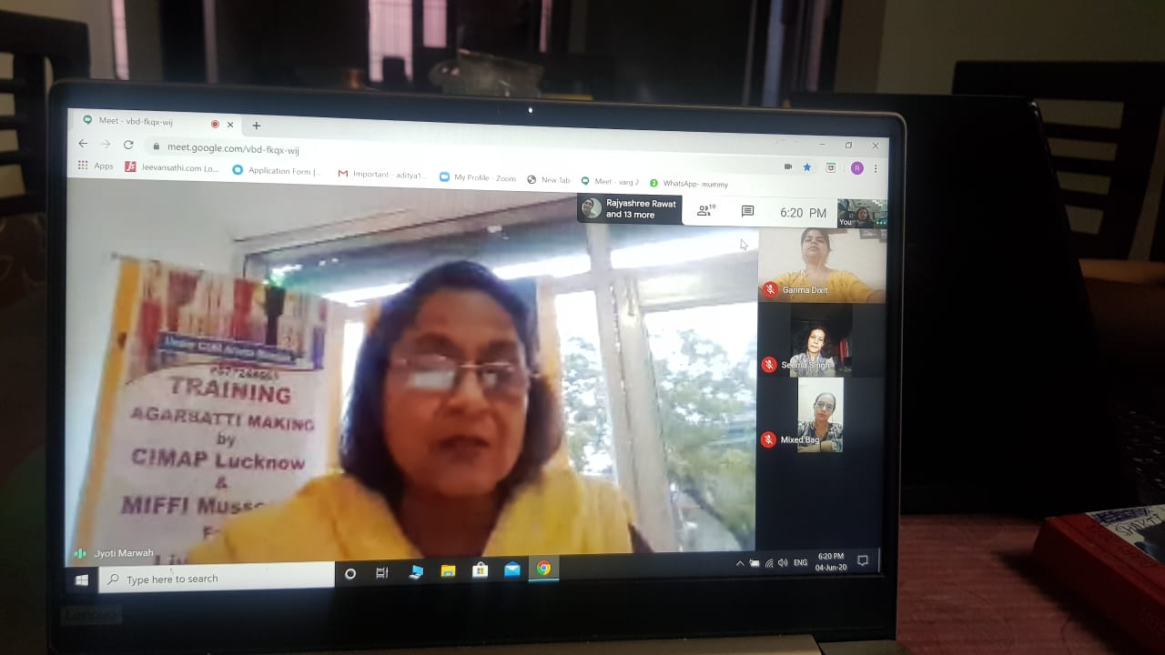
DAY 3
TITLE: World Environment Day
DATE:5/6/2020

The third day of Shakti E Varg was marked by the celebrations of World Environment day (5, June 2020). The Satra started with the singing of Varg song by the Shakti members. The guests for the third day were Dr. Kusum Arunachalam (Professor, Doon University) and Dr. Mahesh Bhatt (President, Vigyan Bharti).
Dr. Kusum delivered her lecture on Environment and its conservation, she also emphasised on the fact how there had been positive changes seen on earth due to temporary absence of humans. She also conveyed the need for sustenance of the environment in a positive way even after Covid -19. The lecture mainly focussed on important topics such as Biodiversity conservation: how each and every life on this planet plays an important role in the ecosystem, Green economy, various eco warriors of Uttarakhand such as Gaura Devi, various festivals dedicated to environment preservation in Uttarakhand such as Maitri and how women play a major role in biodiversity conservation in Uttarakhand. Dr. Mahesh Bhatt in his lecture gave a brief introduction to Covid 19 and also emphasised to focus upon mental health during this time when maximum people are in isolation. There was also an increase in the number of crimes, domestic violence cases which were needed to be focussed upon and spoken about. The Satra was concluded with E games, ShantiMantra and a thank you note to all.
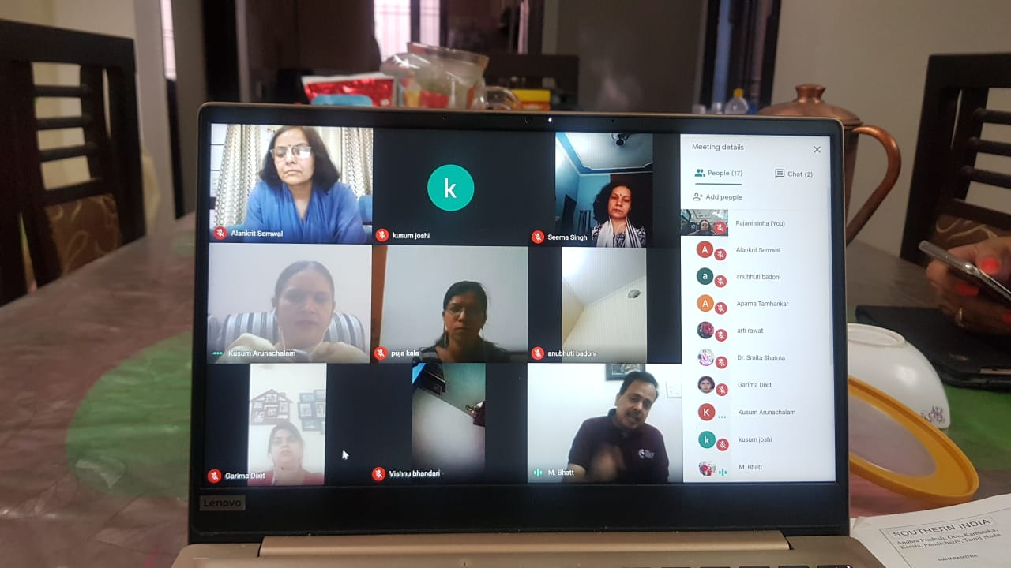
DAY 4
TITLE: ENLIGHTENMENT SESSION
DATE:6/6/2020

The fourth day of Shakti E Varg started off with the Varg song sung by the Shakti members. The guests for the fourth day were Shree Yudhveerjee (PrantPracharak, Uttarkhand) and Prajatantrajee (Sangathan Mantri, Vigyan Bharti). The first lecture was delivered by Shree Yudhveerjee where he enlightened everyone on major characteristics that should be possessed by the members of the group or Sangathan. The major characteristics that were highlighted are the member of the organization should have faith towards his organization, ability to keep everyone together, ability to imbibe the goodness and removal of bad habits if any, confidence, gratitude, should have a clean personality such that he/she is never blamed, should be able to do the job well, listening to everyone’s opinions, have a sense of responsibility and service to society, time management, cheerful, positive, intellectual and should stand above any discriminations and take decisions accordingly. The second lecture for the day was delivered by Shree Prajatantrajee which mainly focussed on the power of women in society and how they happen to be the epicentre of the family and its first teacher. He concluded his lecture by glorifying bravery and power of various women in Uttarakhand throughout history such as TiluRauteli, Gaura Devi, Rani Karnavati etc.
The fourth day Satra was also attended by Smt, Leena ji, SmtChandiAswaljee, SmtPurnakalaSamantjee, Shree Omprakash jee and Professor H.C. Purohit jee. We were honoured to have them, the programme was concluded with the Shanti Mantra and a thank you note to all.
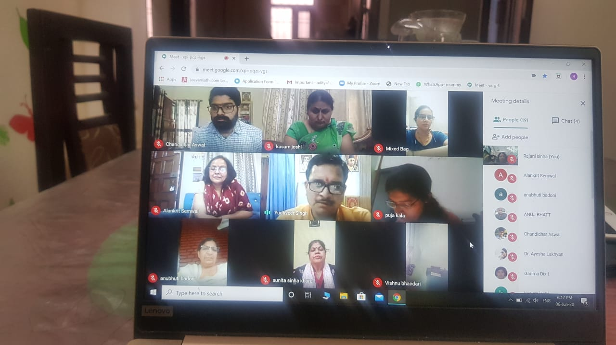
CULTURAL PROGRAMME
DATE:7/6/2020

On the last day a colourful closing ceremony was organized where in all the members participated in their own ways. Various events such as dance, singing, Jagar recital etc were held. Jagar and Dance presented by Kusum Joshi Ji and her team, song by Neelam Baloni, dance and Nanda song presented by SmitaSemwal ji, poem by Sunita Khare ji, dance by Pratibha ji, Ghazal by Rajni ji, poem by Krishna ji, Garima ji Poetry were beautifully presented by all. Bindu ji, Sudha ji, National President and Leena ji, were present in the cultural event which was concluded by the Shanti mantra and a thank you note for the exemplary performances and energetic participation by all Shakti sisters.
