PRATIBHA SHAKTI VIDARBHA
ANNUAL REPORT
1ST APRIL 2019 TO 31ST MARCH 2020

15th June 2019 :
SHAKTI HELD ITS ANNUAL GENERAL MEETING AT NEERI, NAGPUR
The meeting was organized by Pratibha Shakti on 15th and 16th June at NEERI premises.
The AGM was chaired by President Dr. Sudha Tiwari, Gen Sec. Dr. Ankita Bohare, coordinator Binduji Suraj, Joint Sec. Dr. Leenaji Bavdekar. We were blessed to have Dr. Shankarrao Tatwawadi Founder Member and Mentor, Gen. Sec. Shri. Jayant rao Sahasrabuddhe and Sec. Shri. Sudhurji Bhadoria, all from Vidnyan Bharati

Various protocols, theme, one prayer in all units and several common programs to be followed in all units to have evenness throughout the country were discussed.

A hall full packed with members coming from Uttarakhand to Kerala shows we are here to do things and do things in right way, efforts be it in any form, smallest details to mega events can be carried out with team work and we are moving forward with massive support of each other, that's what was experienced by all.

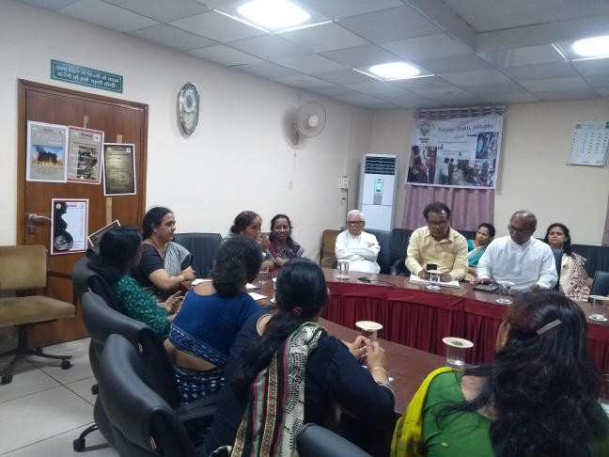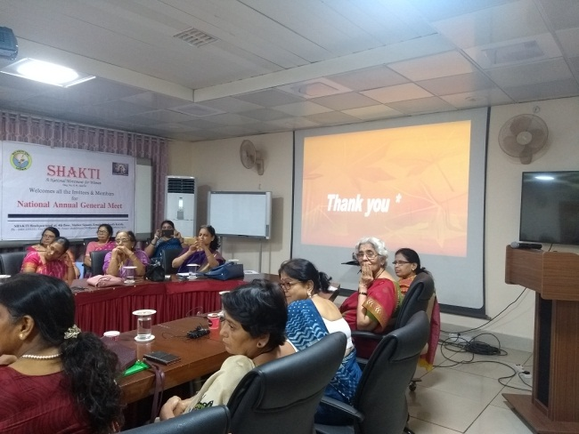

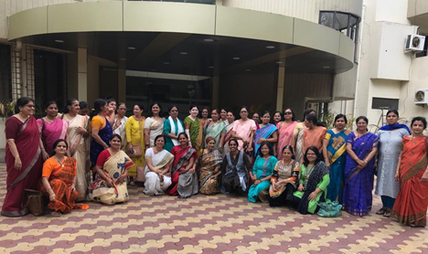

17th September 2019:

SHAKTI WELCOMES DCP VINITAJI SAHU
Recently appointed Deputy Commissioner of Police IPS, Vinita Sahu was welcomed by members of Shakti, a National Organisation for empowerment of women through science and technology. Speaking on the occasion, National President of Shakti Dr. Sudha Tiwari, said that it is a proud moment for Shakti and women of Nagpur to have a dynamic and innovative minded DCP like Vinitaji. It is noteworthy that Vinitaji was awarded for her innovative mobile Police Van at Bhandara. Pratibha Shakti President Varsha Tatwawadi urged for her cooperation, The DCP assured all her support for social cause Shakti is working for. She praised the honesty and dedication of the organisation as she is associated with Shakti since last few years. Advisor of Pratibha Shakti, Dr. Arti Saoji proposed few programs in which her support may be needed.

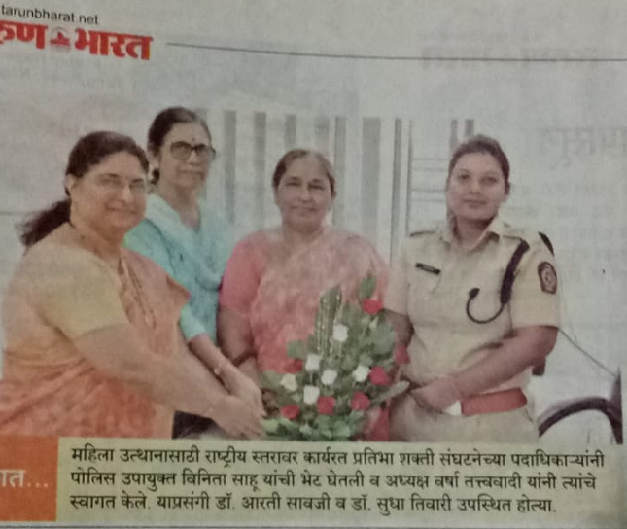

10th October 2019 :

Shakti has done Survey on work life balance of Women scientists and prepared report unvailing of it along with 28 reports ondifferent subjects related with women consisting of 60000 survey samples was done on 24th September 2019 at New Delhi by Shri. Mohanji Bhagwat and Smt. Nirmalaji Sitaraman. The project was done by Drishti under Mahila Samanvay. Forward to this, another program was held at University of Science, Nagpur. Dignitaries present were Governor Maharashtra Hon. Shri. Bhagat Singhji Koshyari, RTMNU Pro-VC Dr. Vinayak Deshpande and other dignitaries.

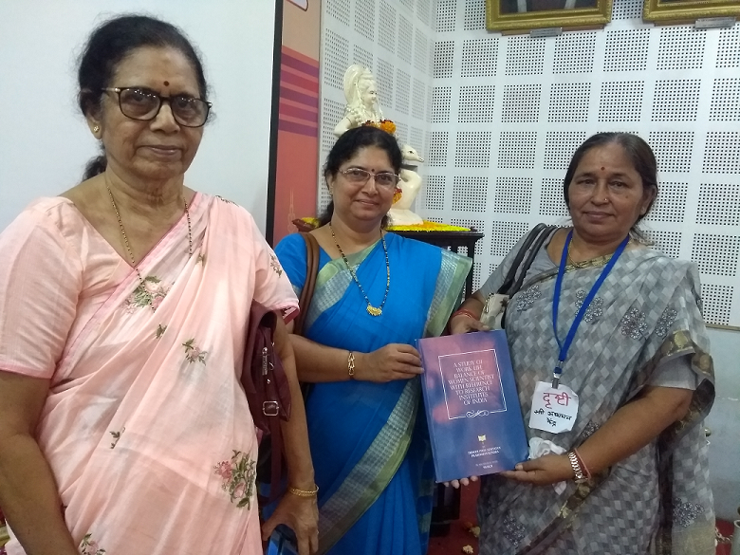

16th December 2019:

Adv. Smita Deshpande attended SAMANWAY BAITHAK at Smruti Bhavan, Reshimbag, Nagpur, which was chaired by Smt. Geeta tai Gunde. Other dignitaries present were Justice Meeratai Khaddakar, Adv. Arti Kulkarni, Smt. Meeratai Kadbe. Adv. Smita Deshpande presented activities and report of Pratibha Shakti.

13th January 2020:

VISIT OF DR. REETA BHATTACHARYA, SECRETARY, SHAKTI:
Being in charge of registration for Mega Expo she visited Nagpur unit regarding outreach for STREE 2020 Conference scheduled at Delhi. Members of Pratibha Shakti held a meeting at Deo Madam’s place and also visited Ahilya Mandir along with Dr. Reeta Bhattacharya and seeked blessings of Poojaniya Smt. Pramilatai Medhe.
Seen in photo - Reetaji, Adv. Smitaji and Varsha Tatwawadi

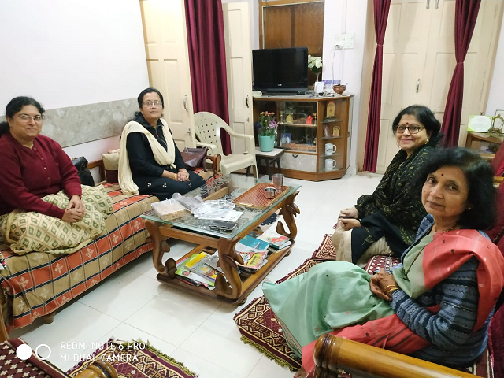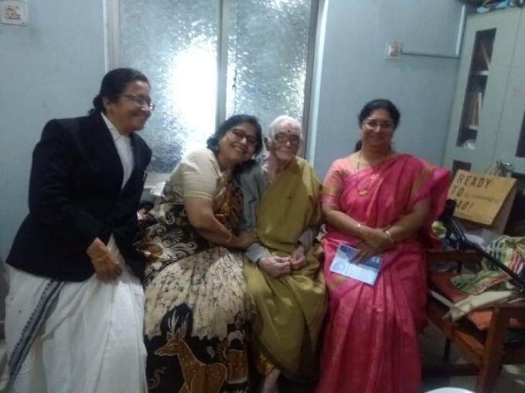

19th February 2020: SHAKTI PRERNA SAMMAN PROFILE :
Varsha Tatwawadi found out a woman farmer working at the grass root level having her own land. She fulfilled the criteria of agricultural methods used in her farm and also preserved the seeds of her crop for better results. Her name is Smt. Mandatai Gawalkar from Gondia district. She holds several certificates to her credit from various organizations. It was decided to bestow Shatki Prerna Puraskar on her, also fondly called “Beej Rakshak”. Following are some pics during the visit there

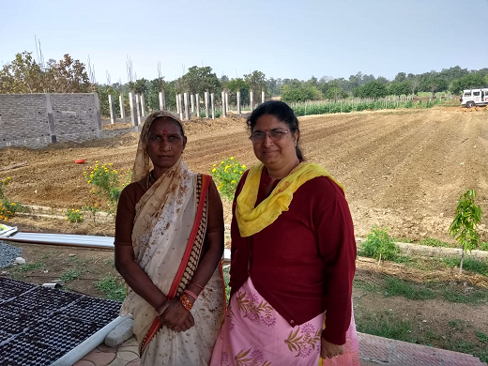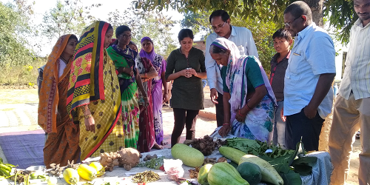

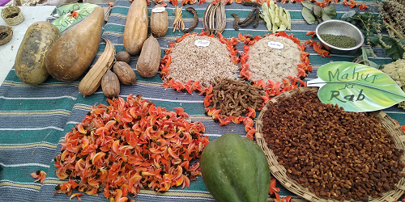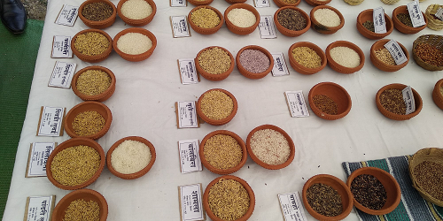

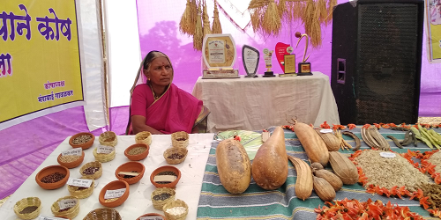

26th February 2020 : OUTREACH STREE 2020 CONFERENCE :

Varsha Tatwawadi visited and covered VNIT departments and concerned Vijnana Bharati members. Brochures and flyers given for students. Few faculties were interested in sending abstracts.

Dr. Arti Saoji distributed brochures and flyers which were put on notice boards at:
Institute of science
Hislop college
Law college
Botany Dept, PGTD

7th March 2020: NATIONAL SCIENCE DAY CELEBRATION :
Pratibha Shakti celebrated National Science Day on 7th March 2020 at Indira Convent School Nagpur. Theme was “Women in Science”. Speaker, Prof. Vaishali Deo highlighted contribution of several well-known women in the field of science. Also, a special interactive session was conducted where “Fear of Mathematics” was tackled giving simple examples. Application of mathematics in day to day life was explained and students enthusiastically participated in problem solutions. Earlier, national and local activities of Shakti were informed by Smt. Varsha Tatwawadi. Pen, namkeen and sweets were distributed to the students who come from a low socioeconomic group. All the school teachers worked hard for the success of this special event.

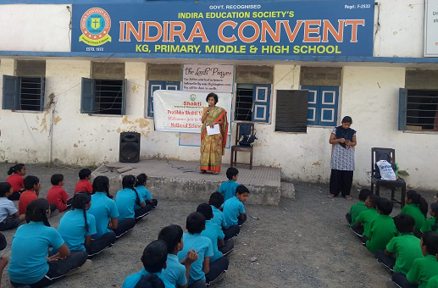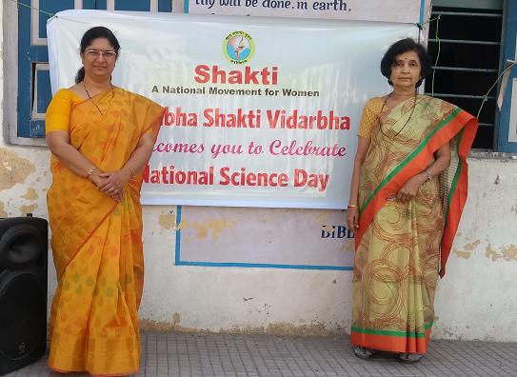

15th March 2020 : WOMEN’S DAY CELEBRATION :
Mahila Diwas was celebrated at Laxmi Narayan Mandir premises, Gajanan Nagar, Nagpur The topic was “ Self Protection for Women”. Speaker : Athlete Chhaya Janabandhu. Women audience which comprised mainly of home makers and some working were guided as to how to deal with sudden attacks by robbers, how to take care of oneself in crowded places, and how to keep self, fit and fine all the time. She said practicing fitness at all ages is beneficial for self and for the society. She demonstrated dealing with untoward incidences efficiently, not to get panicky and keep calm and face situation and turn it into our favour by raising alarm, make emergency call, get help immediately. A very interesting and interactive session indeed ! 30 women participated. A few demonstrations were the ccentre of attraction and a lot of discussions and own stories were shared. Some glimpses :

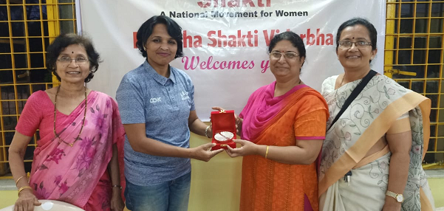

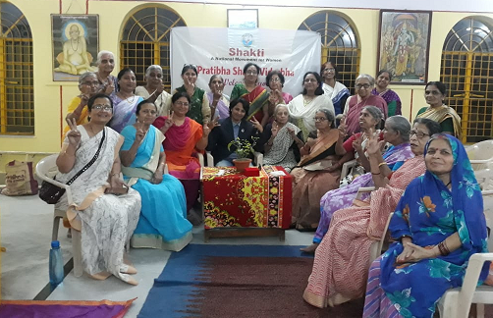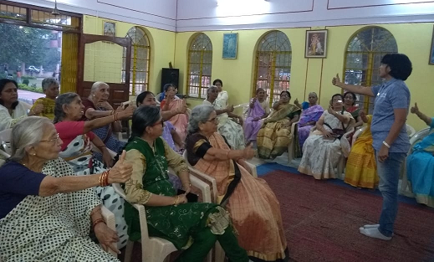
22nd March 2020:
SHAKTI STHAPANA DIWAS : Shakti Sthapana Diwas was scheduled on 22nd March 2020 which got postponed in the wake of COVID 19

ACTIVITIES DURING COVID 19 CONDITION : Several members from Pratibha Shakti donated to the needy in the form of kind and cash during the lockdown period. Food packets for migrants, masks for medical and paramedical staff, masks for COVID 19 warriors including Police, sweepers, vegetable vendors who were running essential services risking their own lives etc were distributed individually by members.

Dr. Arti Saoji on You Tube on behalf of National Aerobiological Society appealed in local languages on Covid pandemic awareness program. She very simplistically explained about the Corona virus its size and behaviour etc. and in later part she explained and urged everybody to take precautions, follow instructions strictly and stay safe, stay healthy.

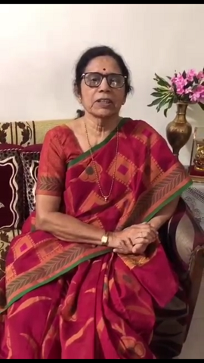

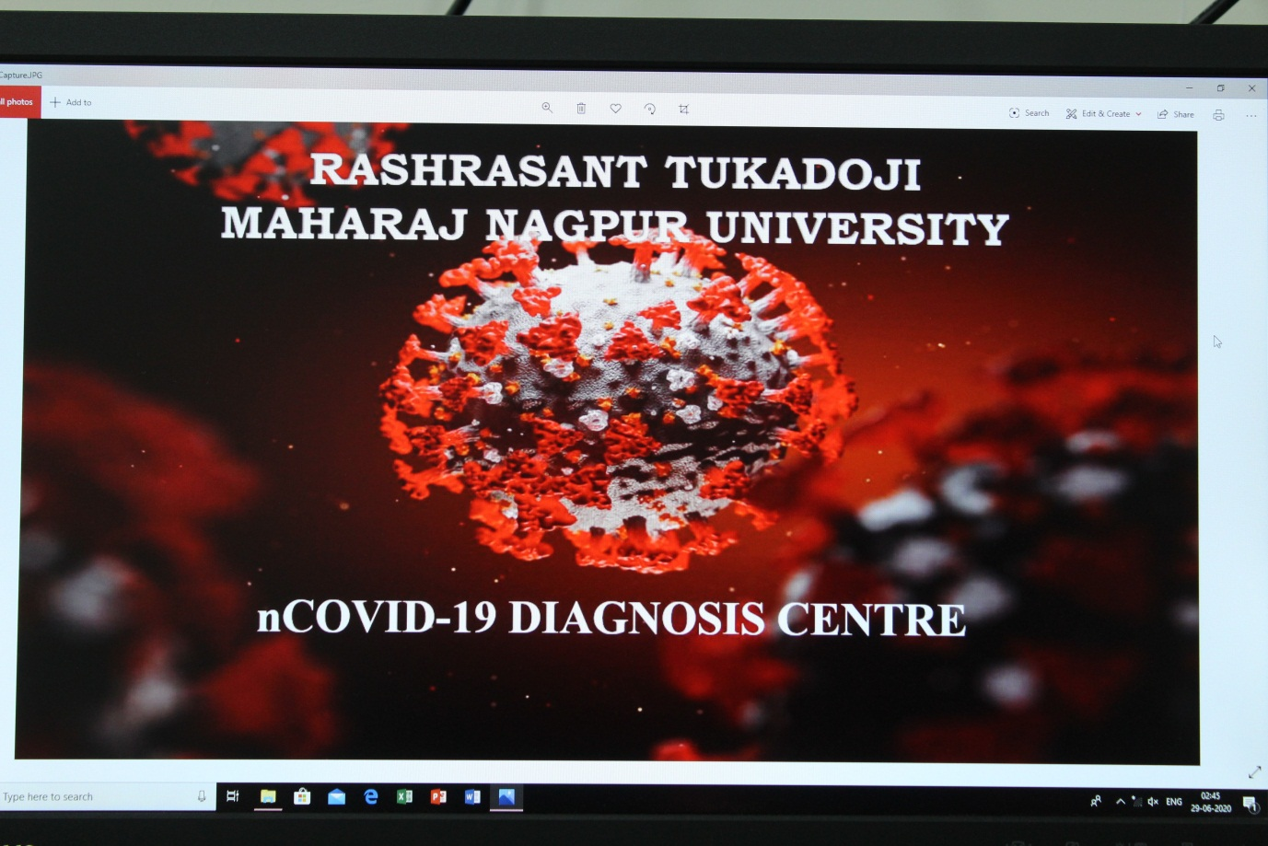

Keeping in mind, the social responsibility of one of the oldest academic institutions in the central India, Rashtrasant Tukadoji Maharaj Nagpur University has come forward to establish COVID-19 Diagnostic Laboratory. Accordingly, Dr. Arti Shanware (Director, Rajiv Gandhi Biotechnology Centre) and other members of her research team have entrusted the responsibility to explore the feasibility of the University providing necessary support for setting up and running the said laboratory at University premises.
The COVID 19 DIAGNOSIS CENTRE of Rashtrasant Tukadoji Maharaj Nagpur University, Nagpur is established at par with the ICMR Guidelines. It is divided into the Sample receiving area, where the samples will be received and patients SRF details will be verified. Next is the Sample Processing & Viral RNA Extraction area, followed by PCR Mix & Template Addition Room. This plate will be finally moved to the RT-PCR Room, where the Real Time PCR machine will analyze the samples and display & record the results. These results will be uploaded in the ICMR & other government web portals in the Data Entry & Analysis Room which is provided with high speed internet.
Summarily, all efforts are being taken up by the concerned team members and the administration of RTM Nagpur University at top priority to establish the COVID-19 Diagnostic Laboratory in the University.
The University is leaving no stone unturned to co-operate with the local administration in handling the COVID-19 pandemic.
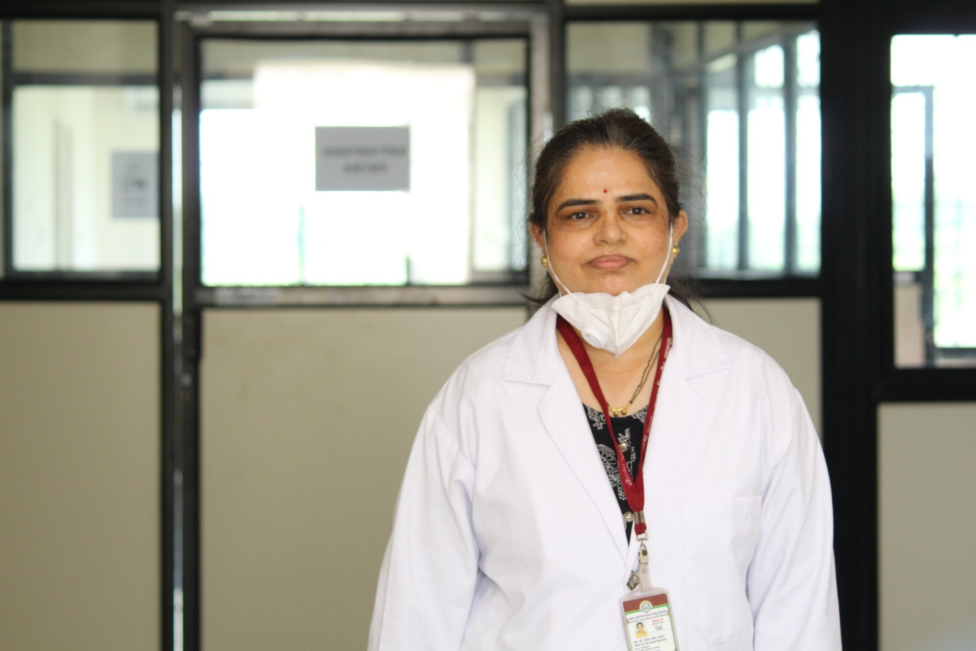
Dr. Arti Shanware, Director, Rajiv Gandhi Biotechnology Centre
&
Principal Investigator, nCovid-19 Diagnosis Centre,
Rashtrasant Tukadoji Maharaj Nagpur University,
Nagpur

